Maths at Clayton Village Primary School

The importance of maths

‘The only way to learn maths is to do maths.’ Paul Halmos
‘Pure mathematicians just love to try unsolved problems-they love a challenge.’ Andrew Wiles

‘ I enjoy challenging and stretching the children’s understanding.’ Miss Clifton Y6 teacher

‘ Maths has calculations and it is fun. I like learning new things.’ Y6 child
‘ I like maths because I like writing and working with numbers.’ Y2 child

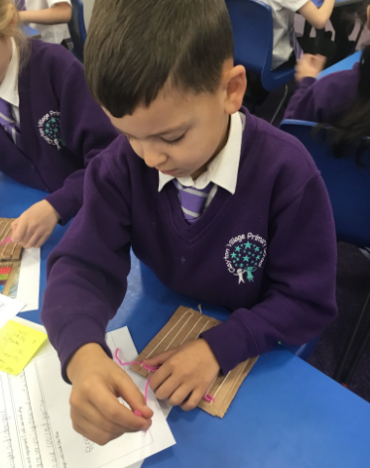

Overview

Mathematics is a creative and highly inter-connected discipline that has been developed over centuries, providing the solution to some of history’s most intriguing problems. It is essential to everyday life, critical to science, technology and engineering, and necessary for financial literacy and most forms of employment. A high-quality mathematics education therefore provides a foundation for understanding the world, the ability to reason mathematically, an appreciation of the beauty and power of mathematics, and a sense of enjoyment and curiosity about the subject.
The national curriculum for mathematics aims to ensure that all pupils:
- become fluent in the fundamentals of mathematics, including through varied and frequent practice so that pupils develop conceptual understanding and the ability to recall and apply knowledge rapidly and accurately.
- reason mathematically by following a line of enquiry and developing an argument, justification or proof using mathematical language
- can solve problems by applying their mathematics to a variety of routine and non-routine problems with increasing sophistication, including breaking down problems into a series of simpler steps and persevering in seeking solutions.

At CVPS, these skills are embedded within Maths lessons and developed consistently over time. It is important that children are able to recognise the importance of Maths in the wider world and that they are also able to use their mathematical skills and knowledge confidently in their lives in a range of different contexts. We want all children to enjoy Mathematics and to experience success in the subject, with the ability to reason mathematically. We are committed to developing children’s curiosity about the subject, as well as an appreciation of the beauty and power of Mathematics.

Maths through school.

Mathematics is an interconnected subject in which pupils need to be able to move fluently between representations of mathematical ideas. The expectation is that the majority of pupils will move through the programmes of study at broadly the same pace. However, decisions about when to progress should always be based on the security of pupils’ understanding and their readiness to progress to the next stage. Pupils who grasp concepts rapidly should be challenged through being offered rich and sophisticated problems before any acceleration through new content. Those who are not sufficiently fluent with earlier material should consolidate their understanding, including through additional practice, before moving on.
To ensure whole school consistency and progression, the school follows adapts when necessary the White Rose Schemes of Learning from Reception to Year 6. The White Rose Schemes of Learning break down the Early Years Outcomes and National Curriculum into small steps to ensure that the objectives are taught progressively. Alongside this, to ensure that staff at all levels understand the pedagogy of the approach, the DfE approved ‘Power Maths scheme and the NCETM Spine materials are used to enhance staff subject knowledge and provide conceptual and procedural fluency.

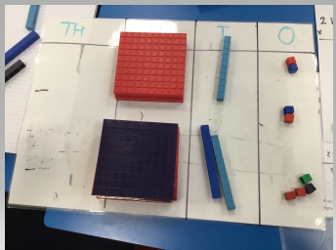

New concepts are shared within the context of a real world problem. This promotes an awareness of maths in relatable real-life contexts that link to other areas of learning. Maths lessons take the form of ‘I do’ (Teacher modelling of concrete, pictoral and abstract procedures and concepts.) The use of stem sentences can support this. ‘We do’ which is children’s time to work in groups, pairs or individually to apply the procedures and concepts modelled to them. ‘I do’ is independent application of the procedure and/or concept at a level of support or challenge that is appropriate to individual children. In years 3 to 6, break time is used for AFL of the children’s conceptual and procedural understanding. The teacher looks at children’s work and makes a note of how they can be further challenged or supported depending on the understanding they have demonstrated so far at this stage in the lesson. The children are then grouped according to the level of support or challenge needed. The children will then complete a learning task which is at their level. Challenge can take the form of ‘rich and sophisticated’ problems from the White Rose Maths Small Steps guidance, NCETM and ‘I see reasoning/problem solving resources. Power Maths also provides a reflect task if needed for the children to review, reason and reflect on learning and enables the teacher to gauge their depth of understanding. Support and challenge should happen throughout the lesson but the children should work on the same learning objective to ensure that mastery for all. The I do, We do, You do sequence can happen repeatedly within a lesson if this supports the children’s understanding. In Reception and Year 1, children access ‘discovery learning’ after whole class direct teaching sessions. During this time, children will work with an adult on a focus task appropriate to their level of understanding and they will also be given the opportunity to practice their new skills and/or consolidate previous mathematical knowledge in the different areas of the classroom.
Concrete, pictoral and abstract methods are set out in our calculation policy and are carefully chosen and modelled in lessons. The representations being used need to pull out the concept being taught and in particular the key difficult point. The representation will create an image in the learner’s mind which will progress them on to being able to complete abstract calculations without needing to rely on the concrete or pictoral representation.

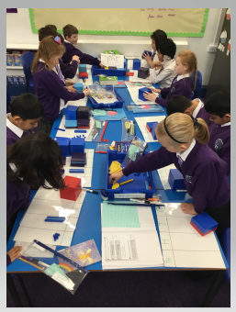

Fast Maths

From Year 1 to Year 6, children will practice and consolidate their learning in fast maths sessions. In EYFS, daily counting and number recognition take place in ‘Fast Maths’ sessions. Fast maths is the practice of facts the children need to know from memory or the practice of calculation methods already taught with the aim of becoming increasingly fluent. Fast maths takes place a minimum of 3 times a week. Children are taught and modelled strategies for answering the questions as fluently as possible. Concrete and pictoral resources are available for children who require them. Flexible guided groups, led by an adult are used to support the children that need it. Assessment of fast maths results and strategies, allows teachers and leaders to see who needs further support. Fast maths objectives are taken from our arithmetic long term plan.

Year 4 Timestable Check

The Multiplication Tables Check (MTC) is a key stage 2 assessment to be taken by pupils at the end of year 4 (in June). The purpose of the MTC is to make sure the times tables knowledge is at the expected level.
The MTC is an online test where the pupils are asked 25 questions on times tables 2 to 12. For every question you have 6 seconds to answer and in between the questions there is a 3 second rest. Questions about the 6, 7, 8, 9, and 12 times table come up more often. The questions are generated randomly based on the rules of the MTC.
In Year 4 we begin to prepare early and build a daily routine practising our times tables. With our regular practise we will learn our times tables, gain confidence and become prepared for the test.
After the test the system will automatically give a score the MTC. At the end of the assessment a total score out of 25 will be reported to each school and this will be shared with parents/carers. There will be no expected standard threshold for the MTC.

Policy

Please refer to the calculation policy to see the progression of written methods for the 4 calculations that we follow at CVPS. It is not organised into year groups but instead stages of learning. Teachers should check the Early Years Outcomes or the National Curriculum to know what their year group’s expectation is. Also within the calculation policy, vocabulary is listed for each calculation to enhance children’s recognition and support delivery throughout school. The school has a fraction policy that should be referred to when teaching fractions. The progression in mental calculations is also used to ensure there is progression when teaching mental calculations.

Supporting maths

At CVPS, we are committed to teaching our pupils to become skilled mathematicians who develop fluency, reasoning and problem solving skills as they move through school but some children find this more difficult than others. Children who need further support with mathematical concepts are supported in a variety of ways. They will be initially supported through continuing to use concrete and pictorial representations to develop and deepen their understanding; be supported 1:1 with an adult; be supported in a small group in maths lessons and have post learning sessions addressing their gaps following an assessment. This ensures that understanding of maths concepts are achievable for all children.

Resources

Every child in school is given the opportunity to use concrete and/or pictoral resources to aid their maths understanding. Children are also given access to Maths shed and TT Rockstars which can be accessed at home to help support their fluency of timestables.

Assessment

Both formative and summative assessments are used to assess children’s mathematical understanding. In every lesson, formative assessment takes place in the form of discussion with children, observing children and feedback on children’s work in maths books. This allows staff to move rapid graspers quickly on to rich problem solving and to support children who need more practice, either within the lesson or before the next lesson. In year 2 to 6, summative assessment takes the form of end of unit checks (Year 1 onwards) and formal assessments (Year 2 onwards) throughout the year which allows staff to assess who has retained key knowledge and skills and who needs further support.

