West Bradford LAP

Fraction Policy
Pencil and Paper Procedures
Stages 1-6

Policy Date: September 2020 Review Date: July 2021

Overview
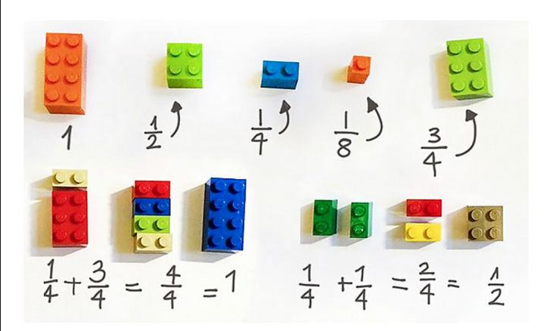
0 0.1 0.2 0.3 0.4 0.5 0.6 0.7 0.8 0.9 1
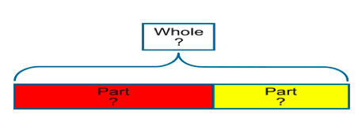
0 0.1 0.2 0.3 0.4 0.5 0.6 0.7 0.8 0.9 1
½ | ½
½

$$\frac{2}{4}$$

Strand | Stage 1 | Stage 2
Recognise fractions, decimals and percentages | N/C: recognise, find and name a half as one of two equal parts of an object, shape or quantity  N/C: recognise, find and name a quarter as one of four equal parts of an object, shape or quantity | N/C: recognise, find, name and write fractions 1/3, 1/4, 2/4 and3/4 of a length, shape, set of objects or quantity  N/C: write simple fractions e.g. 1/2 of 6 = 3 and recognise the equivalence of two quarters and one half.
 | 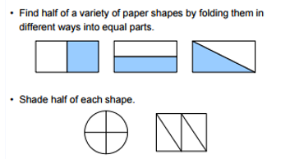  Shade ½of this shape yellow.  ½ ½  Shade ¼of this shape yellow  ¼ ¼ ¼ ¼  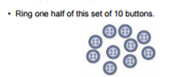 | 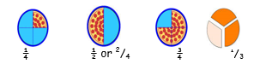  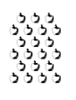  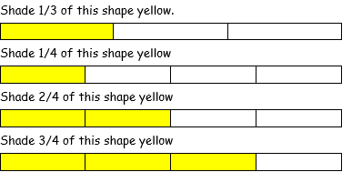  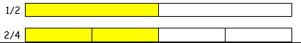  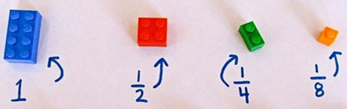
Strand | Stage 1 | Stage 2
Counting fractions, decimals and percentages | N/A | N/C: Counting fractions up to ten starting from any number.  N/C: To be able to recognise that 1/2 and 2/4 are equivalent.
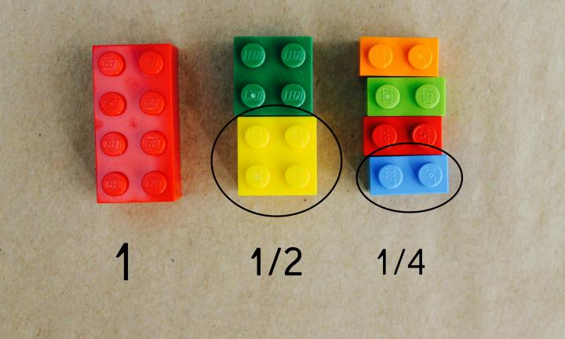

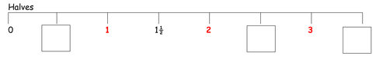

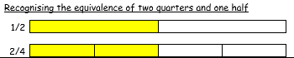

Spot the mistake What comes next?
7, 7 ½ , 8, 9, 10 5 ½, 6 ½ , 7 ½ , …., ….
8 ½, 8, 7, 6 ½, 9 ½, 9, 8 ½, ……, …..
...and correct it.

Strand | Stage 1 | Stage 2
Comparing, ordering and rounding fractions, decimals and percentages | N/A | N/A

Strand | Stage 1 | Stage 2
Adding and subtract fractions, decimals and percentages | N/A | N/A

Strand | Stage 1 | Stage 2
Multiplying and dividing fractions, decimals and percentages | N/A | N/A

Strand | Stage 1 | Stage 2
Equivalent fractions, decimals and percentages | N/A | N/C: Recognise the equivalence of $\frac{2}{4}$ and $\frac{1}{2}$.
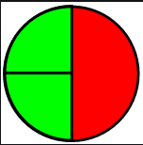
$$\frac{1}{2}$$
$$\frac{1}{4}$$
$$\frac{1}{4}$$

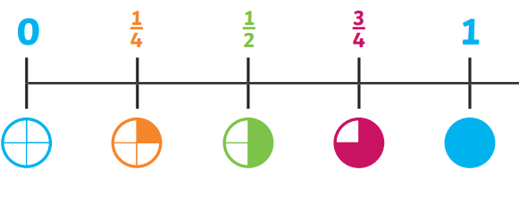

Strand | Stage 1 | Stage 2
Convert between fractions, decimals and percentages | N/A | N/A

Strand | Stage 3 | Stage 4
Recognise fractions, decimals and percentages | N/C: recognise, find and write fractions of a discrete set of objects: unit fractions and non-unit fractions with small denominators | N/C: recognise and show, using diagrams, families of common equivalent fractions
 | 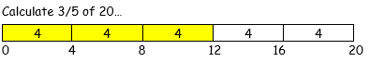  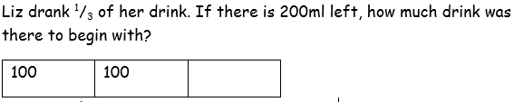  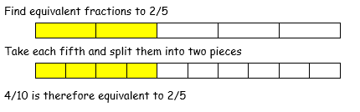  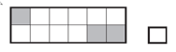  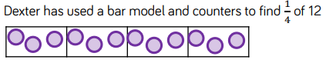  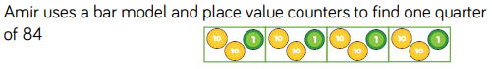 | 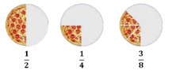  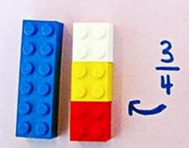  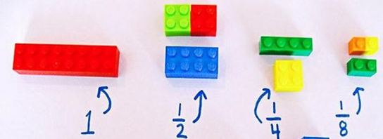  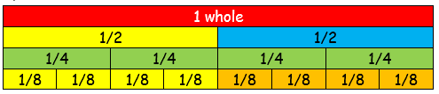  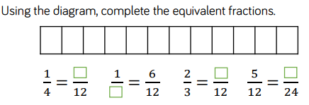  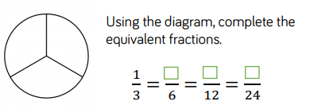
Strand | Stage 3 | Stage 4
Counting fractions, decimals and percentages | N/C: Count up and down in tenths;  N/C: Recognise that tenths arise from  N/C: Dividing an object into 10 equal parts. | N/C: Counting in Fractional Steps  N/C: Count up and down in hundredths; recognise that hundredths arise when dividing an object by 100 and dividing tenths by 10
 | 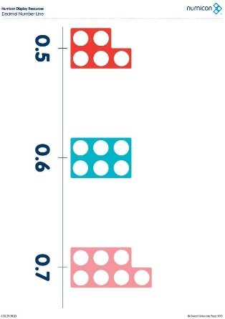  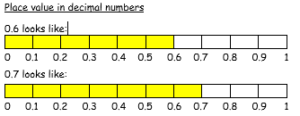  Fill in the missing number-  1.1 1.2 __ 1.4 __1.6 ___1.8  Circle the mistake -  1/10, 2/10, 3/10, 5/10, 6/10, 7/10 | 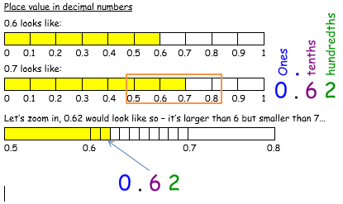  Spot the mistake-  sixty tenths, seventy tenths, eighty tenths, ninety tenths, twenty tenths  … and correct it.  What comes next?  ⁸³/₁₀₀, ⁸²/₁₀₀, ⁸¹/₁₀₀, ___, ___  ³¹/₁₀₀, ⁴¹/₁₀₀, ⁵¹/₁₀₀
Strand | Stage 3 | Stage 4
Comparing, ordering and rounding fractions, decimals and percentages | N/C: Compare and order unit fractions and fractions with the same denominator. | N/C: Compare numbers with the same number of decimal places up to two decimal places.
 | 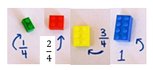  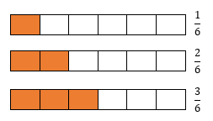  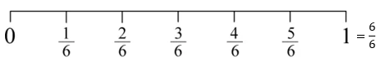  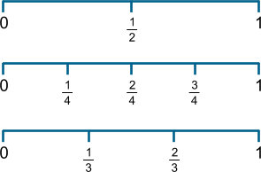  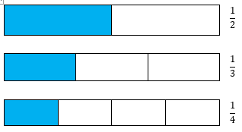 | 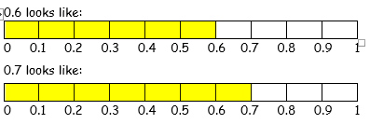  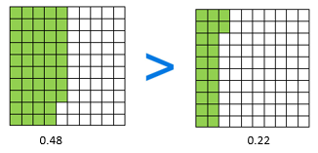  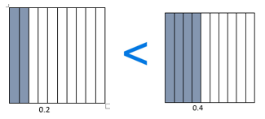  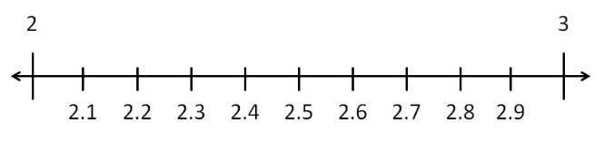  2.6>2.2
 |  | N/C: Round decimals with one decimal place to the nearest ten
0.7 rounded to the nearest whole number…

0 0.1 0.2 0.3 0.4 0.5 0.6 0.7 0.8 0.9 1
Thought process: we can only go to the nearest whole numbers; here they are 0 and 1. 1 is closest, so you round up.

Strand | Stage 3 | Stage 4
Adding and subtract fractions, decimals and percentages | Add & subtract fractions with the same denominator within 1 whole.  (e.g. $\frac{5}{7}$ + $\frac{1}{7}$ = $\frac{6}{7}$) | Add and subtract fractions with the same denominator
 | $\frac{1}{4}$ + $\frac{2}{4}$ = $\frac{3}{4}$  $$\frac{1}{4}$$  + +  $$\frac{2}{4}$$  = =  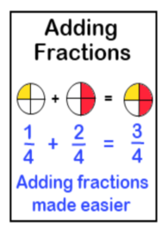  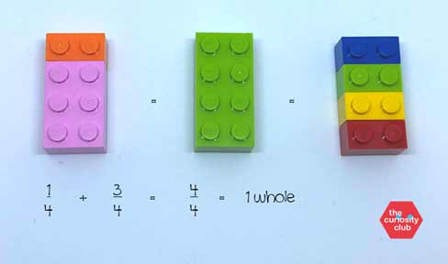  https://www.lauracandler.com/how-to-teach-addition-of-fractions-using-lego-bricks/  $\frac{6}{8}$ - $\frac{3}{8}$ = $\frac{3}{8}$  $$\frac{6}{8}$$  - +  $$\frac{3}{8}$$  = =  $$\frac{3}{8}$$  Thought Process:  As long the denominators are the same, you can add the numerators.  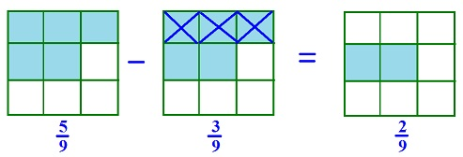 | 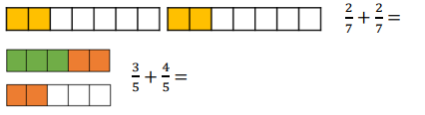  $\frac{3}{4}$ + $\frac{2}{4}$ = $\frac{5}{4}$ or 1 $\frac{1}{4}$  $\frac{6}{7}$ - $\frac{2}{7}$ = $\frac{4}{7}$  $\frac{11}{6}$ - $\frac{4}{6}$ = $\frac{7}{6}$
Strand | Stage 3 | Stage 4
Multiplying and dividing fractions, decimals and percentages | N/C: Count up and down in tenths; recognise that tenths arise from dividing an object into 10 equal parts | N/C: Find the effect of multiplying a one- or two-digit number by 10 and 100, identifying the value of the digits as thousands, hundreds, tens and ones

Strand | Stage 3 | Stage 4
Equivalent fractions, decimals and percentages | N/C: Recognise and show, using diagrams, equivalent fractions with small denominators. | N/C: Recognise and show, using diagrams, equivalent fractions with small denominators.
 | 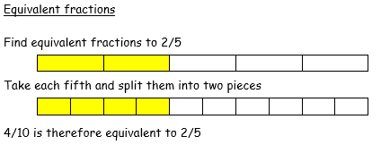  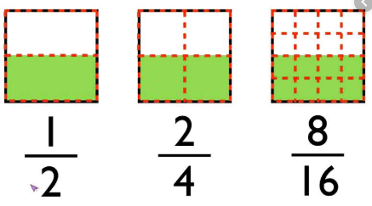  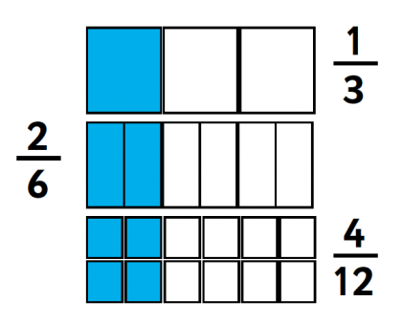  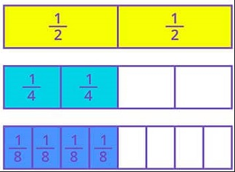 | 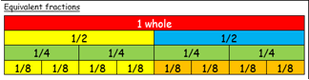  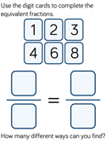  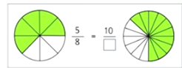
 |  | Recognise and write decimal equivalents of any number of tenths or hundredths; recognise and write decimal equivalents to $\frac{1}{2}$,$\frac{1}{4}$,$\frac{3}{4}$ .
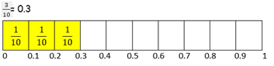

$$\frac{1}{4}$$ | $$\frac{1}{4}$$ | $$\frac{1}{4}$$
0 0.25 0.5 0.75 1

Strand | Stage 3 | Stage 4
Convert between fractions, decimals and percentages | N/A | N/A

Strand | Stage 5 | Stage 6
Recognise fractions, decimals and percentages | N/C: recognise the percent symbol (%) and understand that percent relates to "number of parts per hundred", and write percentages as a fraction with denominator hundred, and as a decimal fraction  N/C: recognise mixed numbers and improper fractions and convert from one form to the other and write mathematical statements | N/A
 | 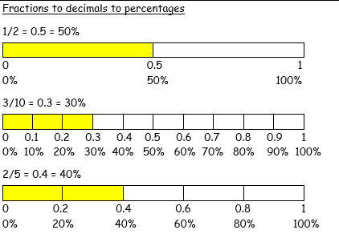
Strand | Stage 5 | Stage 6
Counting fractions, decimals and percentages | Consolidate learning from stages 2 - 4 | Consolidate learning from stages 2 - 4
Strand | Stage 5 | Stage 6
Comparing, ordering and rounding fractions, decimals and percentages | N/C: Compare and order fractions whose denominators are all multiples of the same number. | N/C: Compare and order fractions, including fractions > 1.
 | 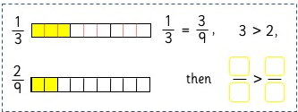  Give an example of a fraction that is more than three quarters.  Now another example that no one else will think of.  Explain how you know the fraction is more than three quarters.  Imran put these fractions in order starting with the smallest. Are they in the correct order?  Two fifths, three tenths, four twentieths  How do you know? | 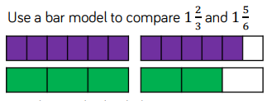  Compare $1\frac{3}{4}$ and $1\frac{1}{3}$ using a numberline.  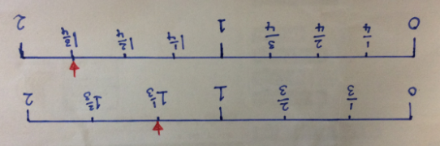  Sam put these fractions in order starting with the smallest. Are they in the correct order?  Thirty three fifths  Twenty three thirds  Forty five sevenths  How do you know?  Give an example of a fraction that is greater than 1.1 and less than 1.5.  Now another example that no one will think of. Explain how you know.
 | Round decimals with 2 decimal places to the nearest whole number or to one decimal place.
Round 0.62 to one decimal place. 0.6 is the closest.
0.62

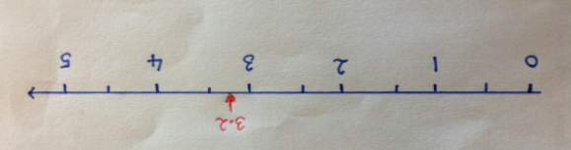
Round 3.2 to the nearest whole number. 3 is closest.

Do, then explain
Circle each decimal which when rounded to one decimal place is 6.2. 6.32 6.23 6.27 6.17
Explain your reasoning.

Strand | Stage 5 | Stage 6
Adding and subtracting fractions, decimals and percentages | N/C: Add and subtract fractions with the same denominator and multiples of the same number | N/C: Add and subtract fractions with different denominators and mixed numbers using the concept of equivalent fractions.
 | $\frac{1}{3}$ + $\frac{2}{4}$ =  $$\frac{1}{3}$$  $$\frac{2}{4}$$  We need find a common denominator that appears in both multiplication tables…12. Split two bars into 12  $\frac{1}{3}$+ $\frac{2}{4}$ becomes $\frac{4}{12}$ + $\frac{6}{12}$  $$\frac{4}{12}$$  + +  $$\frac{6}{12}$$  = $\frac{10}{12}$  $\frac{1}{3}$ + $\frac{1}{2}$ = $\frac{5}{6}$  +  =  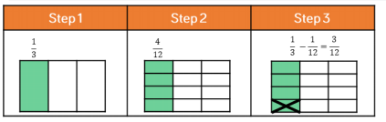  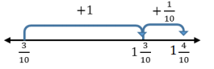  1$\frac{5}{6}$ - $\frac{7}{12}$ becomes 1$\frac{10}{12}$ - $\frac{7}{12}$  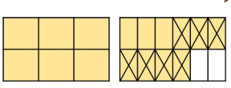 | 2 + $\frac{1}{3}$ =  + = = 2 $\frac{1}{3}$  $\frac{2}{3}$ + $\frac{1}{4}$  +  $\frac{2}{3}$ + $\frac{1}{4}$ =  +  $\frac{8}{12}$ + $\frac{3}{12}$ = $\frac{11}{12}$  = $\frac{5}{3}$ or 1 $\frac{2}{3}$  $\frac{2}{3}$ - $\frac{1}{4}$  -  $\frac{2}{3}$ + $\frac{1}{4}$ =  -  $\frac{8}{12}$ - $\frac{3}{12}$ = $\frac{11}{12}$  X  X X  = $\frac{5}{8}$

Strand | Stage 5 | Stage 6
Multiplying and dividing fractions, decimals and percentages | N/C: Multiply proper fractions and mixed number fractions by whole numbers, supported by materials and diagrams | N/C: Divide proper fractions by whole numbers (e.g. ¹/₃ ÷ 2 = ¹/₆)
 | $\frac{2}{3}$x 3 = $\frac{6}{3}$ = 2 wholes  $\frac{2}{3}$ $\frac{2}{3}$ $\frac{2}{3}$  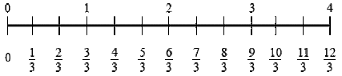 | $\frac{2}{3}$x $\frac{1}{4}$ = $\frac{2}{12}$  $$\frac{1}{3}$$ $$\frac{1}{3}$$ $$\frac{1}{3}$$  $$\frac{1}{4}$$  $$\frac{1}{4}$$  $$\frac{1}{4}$$  $$\frac{1}{4}$$  $$\frac{1}{4}$$

Strand | Stage 5 | Stage 6
Equivalent fractions, decimals and percentages | N/C: identify, name and write equivalent fractions of a given fraction, represented visually, including tenths and hundredths | N/C: use common factors to simplify fractions; use common multiples to express fractions in the same denomination
 | 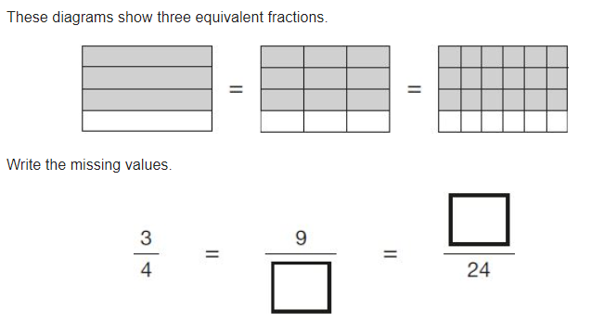  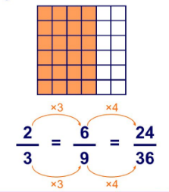 | $\frac{8}{12}$ of the counters are blue.  $\frac{2}{3}$ of the rows are blue.  ÷4  $\frac{8}{12}$ = $\frac{2}{3}$  ÷4  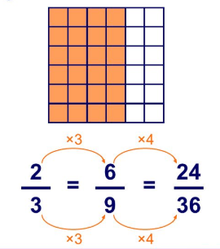
 | N/C: Recognise mixed numbers and improper fractions and convert from one form to the other and write mathematical statements > 1 as a mixed number
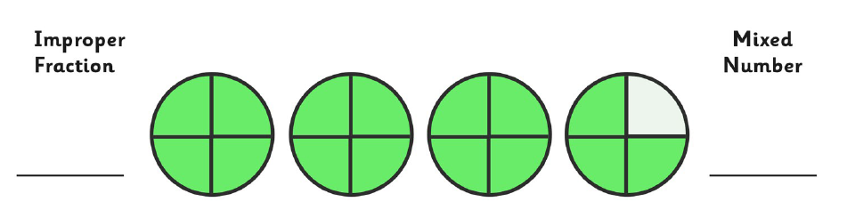

3
3
4

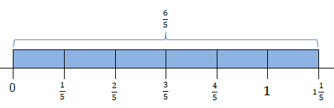

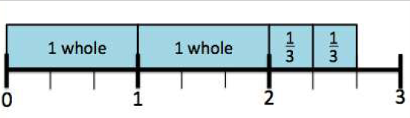

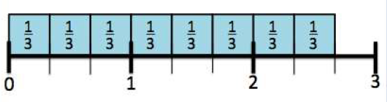

Strand | Stage 3 | Stage 4
Convert between fractions, decimals and percentages | N/C: Recognise and use thousandths and relate them to tenths, hundredths and decimal equivalents | - N/C: Associate a fraction with division to calculate decimal fraction equivalents (e.g. 0.375) for a simple fraction (e.g. ³/₈)

