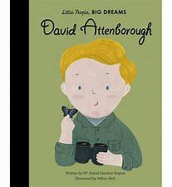  Spring – Off on our Travels  Reception – David Attenborough |  | Experiences:  This term the children will learn about the roles of special people in society who help us and their personal journeys, for example, the police, the fire service and many more. The children will learn about road safety, take their own traffic surveys and take a journey of their own on a bus and round their local area on foot. The children will meet people from the emergency services, a travel agent and a bus driver and have the opportunity to ask questions and discuss real life experiences.
Books
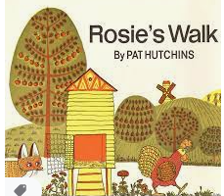
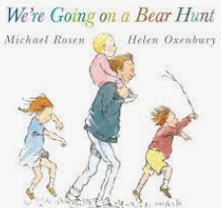
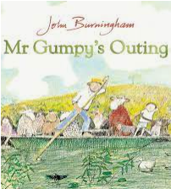
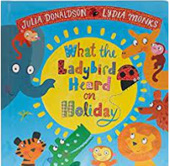
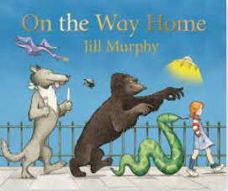
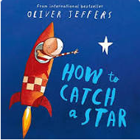
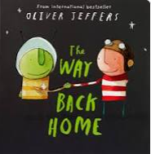
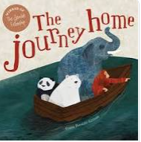

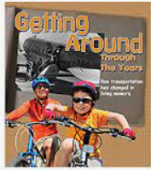
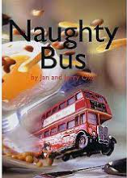
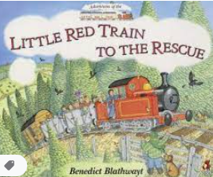
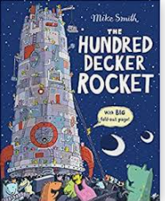
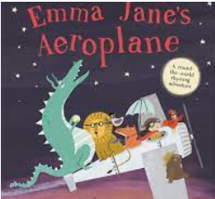
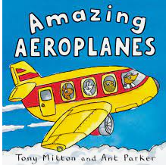
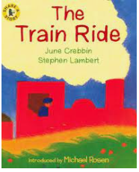
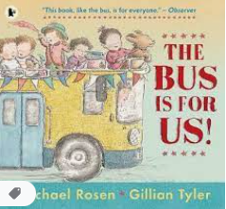

Key Vocabulary

Friends, family, religion, culture, celebration, transport, traffic, car, bus, train, aeroplane, helicopter, boat, far/near, map, wheels, bus/ depot/station, timetables, short/long, airport, water, harbour, boat, car park, park, wood, people, places, holiday, England, UK, the world, space, rocket, stars, push, pull, forces, air, town, city, village, country, seaside, mountains, jungle, forest, journey, destination, weather, climate, hot, dry, cold, wet, tropical, warm, temperature, rain, sunshine, day, night, push, pull, forces, turn, twist, squeeze, press, pat, hard, soft, go, stop, more, less, quick, fast, slow
Communication and Language  Skills:  Listening, attention and understanding:  - To listen carefully to friends and adults  - Ask relevant ‘who and when’ questions  - Make relevant comments on the characters and the plot of the story and justify answers  - To join in with well-known stories such as ‘Were Going on a Bear Hunt’ and song  - Have a back and forth conversation with an adult or a friend about the same topic  Speaking:  - To talk in front of a small group using one sentence  - To use conjunctions such as ‘but and because’  - To express ideas and feelings in the present and future tense  - To participate in small group discussions offering own ideas (I think…)  - To use recently introduced vocabulary in a different context (during discovery) | Expressive Arts and Design  Skills:  Creating with Materials:  - To begin to add body and more detail to drawing of a human figure  - To begin to use a sketchbook to record what they see and collect and record new processes and techniques  - To safely use and explore a variety of materials, tools and techniques  - To experiment to create different textures  - To join different textile surfaces together using glue and embellish with buttons and beads  - To choose particular colours to use for a purpose  - To construct with a purpose in mind, using a variety of resources  Being Imaginative and Expressive:  - To discover how to use their voice to create loud and soft sounds  - To listen to different sounds (water, animals etc) and respond with voice movement  - To explore different sounds instruments make  - To explore body percussion and talk about rhythm and pulse  Winter Landscapes  Use white and coloured chalk on black paper to create wintry scenes  Solar Systems  Drawing planets/space scenes onto black paper  Rain and Snow  Drawing with a white wax crayon, painting over with watered down paint, watercolour or coloured ink to create a rainy/snowy scene.  Painting Space  Painting planets, the night sky or space scenes onto black paper. Using tools to blend paint together, splatter paint for starts. Cutting paper into a circle after to create planet shapes.  David Hockney  Wintry portraits of East Yorkshire. | Physical Development  Skills:  Gross Motor Skills:  - Throwing and catching  - Ball skills  Fine Motor Skills:  - To cut out curved lines and circles  - To cut out more complicated shapes with straight lines and curved lines  - To accurately draw lines, circles and shapes to draw pictures  - To use tripod grip consistently | Personal, Social and Emotional Development  Skills:  Self-Regulation:  - To recognise their own feelings  - To know how to regulate behaviour using a range of techniques  - To say what you would like to do in discovery time the next day and plan  - Participate in turn taking games with an adult and friend  - To stop play and conversation when asked by an adult and follow a one-step instruction  Managing Self:  - To put their own coat on and fasten it up  - To know the rules of a simple game (snakes and ladders)  - To have confidence to try new activities  - To name healthy and unhealthy foods  - To explain why we need to follow rules of a simple game  Building Relationships:  - To use recently taught strategies when turn taking with a group  - To make a group of friends in class  - To play with different groups of friends in class
Understanding the World
Skills:

Past and Present:
- To use everyday language related to time (present and future)
- To describe main story settings, events and characters
- To talk about the key features of an event
- To explore and compare transport vehicles from the past/present
- Explore how transport has changed over the years

People, Culture and Communities:
- Recognise that children celebrate special times in different ways
- Understand people’s roles in society and how some people can help us (emergency services)

The Natural World:
- To know that the world is bigger than space around the school and Bradford
- To identify a map and know that maps can be used to find countries
- To understand and follow directional language
- To make attempts to draw simple features in their familiar environment
- To attempt to draw a map of a familiar place
- To talk about the world and understand the meaning of land, sea, ocean, earth, space and sky
- To know and recognise signs of Winter
- Plant seeds and observe them growing
- To know and recognise signs of Spring
Trips / Visitors: Police officer, fire fighter, nurse, travel agent, bus driver, local walk

