Rosa Parks Newsletter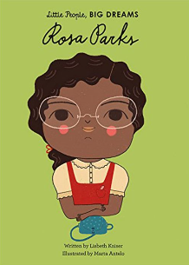

Spring Term 2024

Teacher: Miss Jacobs

Teaching Assistant: Miss Ward

Happy New Year! We hope you had a lovely break over Christmas. Last term, the children settled in well to year 1 and the raise in expectations moving from Reception. In the Spring term, we will be learning about the 4 countries of the United Kingdom. We will also be investigating the consequences of the Great Fire of London, growing our own vegetables in Science and learning about why we should care about the world! Keep up to date with our learning on our class page on the school website.

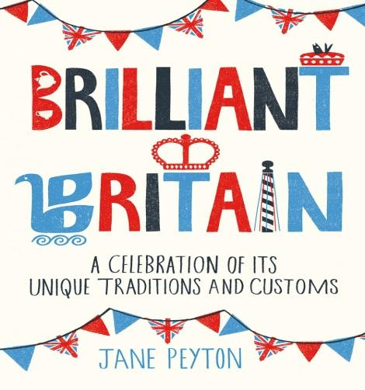

**Spring curriculum**

As mentioned above, we are learning about Britain and why it is ‘Great’ this term. We will be reading famous British stories and legends such as Paddington bear, Loch Ness Monster, Gelert, Finn MacCool and Roaldl Dahl. If you want to do any extra learning at home, you and your child could read some British themed books, taste some traditional food, have a look at some British castles, research some simple facts or think of some questions to get answered at school. If you do any home learning, please bring it into school or upload onto Seesaw to show the rest of the class – we love to see all your extra work!

**Careers Week**

**Note:** We are looking for volunteers for our careers week to talk to classes about your jobs and work. If you would like to volunteer, please contact the school office.

**Reminder**

Just a timely reminder that no toys are allowed to be brought in to school. This is to prevent children being upset if their special toy gets lost or broken.



**Important announcements**

**8.1.24 –**Positive Noticing Day

**18.1.24 –**Census Day

**W/C 29.1.24**– Children’s Mental Health Week

**W/C 5.2.24**– Careers Week

**6.2.24 –**Safer Internet Day

**9.2.24 -**End of half-term

**19.2.24** – School re-opens

**W/C 8.3.24** – British Science Week

**22.3.24** – End of Spring Term

**Family Breakfast**

**11.1.24 –**Emile

**25.1.24** – Attendance

**8.2.24** – Careers Week

Dates for Family Breakfast in Spring 2 to be confirmed.

**PE**

PE is continuing on a Thursday afternoon. Please ensure your child has their named PE kit in school every Thursday. This consists of shorts, house t-shirt and a pair of pumps. Any questions with regards to PE Kits, please see a member of the Year 1 team.

**Reading**

Reading books are handed out on **Fridays** and need to be returned **Tuesdays**. Please log your child’s reading on Boom Reader and read at least three times per week. Library books are changed on **Wednesdays.**

Many thanks for your continued support - The Year 1 Team

To keep updated with what we have been doing in class and other school events, please follow and reply to our twitter account. The Y1 account is @YEAR1CVPS and the school account is @cvprimary1.