History  What happened at Kitty Hawk that changed the world?  Knowledge:  - To understand where in the world and when in the past we are learning about. To understand chronological duration. To understand how events beyond living memory. To learn about the lives of significant individuals in the past who contributed to national and international achievements. | Science  Uses of everyday materials – How do I make my plane fly?  Knowledge:  - Identify and discuss the uses of different everyday materials  - Compare the uses of everyday materials  - Identify and compare the suitability of a variety of everyday materials  Scientific Enquiries:  - How do we complete a fair test? (Which materials make the best airplane? Paper, card, tinfoil, fabric).  Living things and their habitats – Why does this animal live here?  Knowledge:  - Describe how different habitats provide the basic needs for different animals and plants.  - Sort animals into appropriate habitats.  - Describe the conditions in different habitats and how this effects the number and type of animals that live there.  - Identify that most living things live in a habitat suited to them.  Scientific Enquiries:  - Which animals live in South Africa and why? (Research)  - How does the African savannah compare to the School garden?  - Which animals live in Pakistan and why?  - How do the Pakistani mountains compare to the School garden? | Geography  What is it like to live near the coast?  Knowledge:  - Understand geographical similarities and differences through studying the human and physical geography of a small area of the UK (Filey).
Computing  Presentations - animal catchphrase quiz  - Know how to add voice labels to an image  - Know how to import images to a project from the web and camera roll  - Know how to use some build in animations in presentation software. | Emmeline Pankhurst  Spring Curriculum  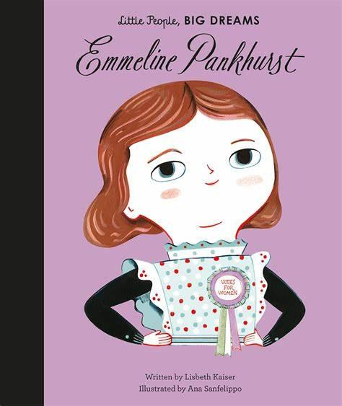 | R.E  How do we know some people were chosen in early life?  Religions: Christianity, Islam, Judaism
PSHE  Relationships Education  - Making friends  - Being a good friend  - Playing/Working with others  - Manners and respect  - Resolving conflict  Living in the Wider World  - What is the internet?  - Personal data  - Online safety  - Online information  - Belonging to a community  - Same and different (diversity) |  | P.E  Dance  - Developing balance, agility and co-ordination  - Perform dances using simple movement patterns  Invasion game - Netball  - Participate in team games, developing simple tactics for attacking and defending
Art  Artist: Clare Caulfield  Drawing  Painting  Printing  Formal Element: Line, Shape, Texture  - Use drawing as a way to express feelings and share ideas  - Draw with light and dark tones – explore light and shadows  - Use vocabulary to demonstrate knowledge and understanding of different types of drawing e.g. line drawing, self-portrait, landscape, etc). | Design Technology  Structures - Baby Bear’s Chair  - Design, make and evaluate.  - Design purposeful, functional, appealing products for themselves and other users based on design criteria.  - Select from and use a range of tools and equipment to perform practical tasks [for example, cutting, shaping, joining and finishing].  - Select from and use a wide range of materials and components, including construction materials.  - Evaluate their ideas and products against design criteria. | Music  I Wanna Play in a Band  - Listen and appraise  - Performance

