History  How did life change during prehistory?  Knowledge:  - Changes in Britain from the Stone Age to the Iron Age (Bronze Age and Iron Age).  What was the Roman Empire?  How did the Romans impact Britain?  Knowledge:  - The Roman Empire and its impact on Britain. | Science  Plants - What gifts do plants give us?  Knowledge:  - Identify and describe the functions of different parts of flowering plants: roots, stem/trunk, leaves and flowers  - Explore the requirements of plants for life and growth (air, light, water, nutrients from soil, and room to grow) and how they vary from plant to plant  - Investigate the way in which water is transported within plants  - Explore the part that flowers play in the life cycle of flowering plants, including pollination, seed formation and seed dispersal  Scientific enquiries:  - Do the biggest fruits have the most seeds?  - How do our plants change over the year?  - What effects how well our plants grow?  Rocks - What treasures can I find by exploring underground?  Knowledge:  - Compare and group together different kinds of rocks on the basis of their appearance and simple physical properties  - Describe in simple terms how fossils are formed when things that have lived are trapped within rock  - Recognise that soils are made from rocks and organic matter  Scientific enquiries:  - How have the rocks/gravestones/buildings/cliffs around us changed over time?  - The geology museum needs our help - How can we identify and sort the different types of rocks?  - Why is Mary Anning important to Paleontologists? |  | Geography  Why do people live near Volcanoes? (Mount Vesuvius/Pompeii)  Country: Italy  Knowledge:  - Locate the world’s countries, using maps to focus on Europe (including the location of Russia) and North and South America, concentrating on their environmental regions, key physical and human characteristics, countries, and major cities  - understand geographical similarities and differences through the study of human and physical geography of a region of the United Kingdom, a region in a European country, and a region within North or South America  describe and understand key aspects of:  - physical geography, including: climate zones, biomes and vegetation belts, rivers, mountains, volcanoes and earthquakes, and the water cycle  - human geography, including: types of settlement and land use, economic activity including trade links, and the distribution of natural resources including energy, food, minerals and water
Computing  AR and VR- designing a playground  - Create my own digital 360 design and bring it into my surroundings through AR | Zaha Hadid  Spring Curriculum  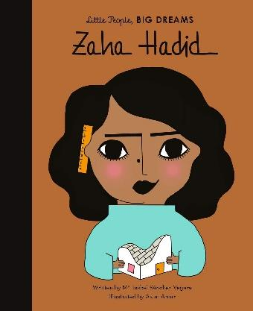 |  | R.E-  What happens if we do wrong?  Religions covered: Hinduism, Islam, Humanist, Christian
PSHE  Living in the wider world  - Jobs and Sectors  - Careers and SkillsTargets and Goals  - Career Routes  - Stereotypes and Women in STEM  Health and Wellbeing  - Personal Safety  - Fire Safety  - Healthy Eating  - What is a Habit?  - Healthy Choices |  |  | P.E  Dance  - Perform dances using a range of movement patterns  - Compare their performances with previous ones and demonstrate improvement to achieve their personal best.  Invasion game - Rugby  - Play competitive games, modified where appropriate and apply basic principles suitable for attacking and defending
Art  Artist:John Martin  Drawing  Painting  3D Clay  Formal Element: Line, Shape, Tone, Pattern, Colour  - To create sketch books to record their observations and use them to review and revisit ideas  - To improve their mastery of art and design techniques, including drawing, painting and sculpture with a range of materials [for example, pencil, charcoal, paint, clay]  - About great artists, architects and designers in history | Design Technology  Cooking and Nutrition. Eating in seasonally  - understand and apply the principles of a healthy and varied diet  - prepare and cook a variety of predominantly savoury dishes using a range of cooking techniques  - understand seasonality, and know where and how a variety of ingredients are grown, reared, caught and processed. | Music  Ukulele  The dragon Song  - Listen and appraise  - playing the glockenspiel  - performance  - improvisation | MFL  French Playground Games – Numbers and Age  - Engage in conversations; ask and answer questions; express opinions and respond to those of others; seek clarification and help.  - Speak in sentences, using familiar vocabulary, phrases and basic language structures.  - Develop accurate pronunciation and intonation so that others understand when they are reading aloud or using familiar words and phrases.  - Present ideas and information orally to a range of audiences.  - Write phrases from memory, and adapt these to create new sentences to express ideas clearly.  - Use familiar vocabulary in phrases and simple writing.

