History  What was life like 10,000 years ago?  How did life change during prehistory?  What does Skara Brae tell us about the Stone Age?  Knowledge:  - Changes in Britain from the Stone Age to the Iron Age (Stone Age). | Science  Evolution and Inheritance – What influences us the most, nature or nurture?  Knowledge:  - Recognise that living things have changed over time and that fossils provide information about living things that inhabited the Earth millions of years ago  - Recognise that living things produce offspring of the same kind, but normally offspring vary and are not identical to their parents  - Identify how animals and plants are adapted to suit their environment in different ways and that adaptation may lead to evolution  Scientific Enquiries:  - What influences the most, nature or nurture? (observing and comparing)  - Who was Charles Darwin and why was he important? (research)  - The longer your beak, the easier it is to pick up your food? True or false? Prove it (pattern seeking STEM) |  | Geography  Who lives in Antarctica?  Knowledge:  - Human geography, including: types of settlement and land use, economic activity including trade links, and the distribution of natural resources including energy, food, minerals and water
Computing  AI- machine learning for kids  - Train an AI model and use it within a program  Computational thinking  - Know how to decompose a design or code to focus on specific parts  - Know how to use abstraction to hide complexity in my design or code  - Know how to recognise and make use of patterns in my design and code  - Know how to critically evaluate my work and suggest improvements | Ernest Shackleton  Spring Curriculum  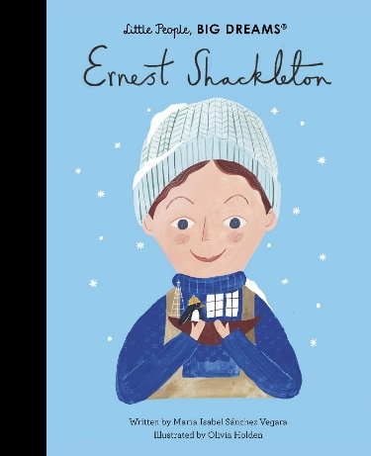 |  | R.E  Why does religion look different around the world? (Part 2)  Religions covered: Hinduism, Sikhism, Buddhism
PSHE  Living in the Wider World  - Help and advice  - Identity & community  - Diversity  - Social media  - Online privacy and data  Health and Wellbeing  - Mental health  - Alcohol  - Drugs  - Body image |  |  | P.E  Invasion game –Rugby  - Use running, jumping, throwing and catching in isolation and in combination  Dance  - Perform dance using a range of movement patterns.  - Compare their performances with previous ones and demonstrate improvement to achieve their personal best
Art  Drawing  Formal element: Line, Shape, Texture  Artist: William De Cooning, Lascaux Caves  - Interpret the texture of a variety of surfaces, using a range of mark-making.  - Develop their mark making through a variety of media – to confidently use media in different ways  - Explore William De Cooning’s connections to Lascaux Caves and associated artworks. | Design Technology  Cooking and nutrition- come dine with me  - Use research and design products fit for purpose.  - Use a wide range of tools and equipment to perform tasks.  - Evaluate ideas and products against their design. | Music  You’ve got a friend in me  - Listen and appraise  - Performance | MFL  French Playground Games – Numbers and Age  - Engage in conversations; ask and answer questions; express opinions and respond to those of others; seek clarification and help.  - Speak in sentences, using familiar vocabulary, phrases and basic language structures.  - Develop accurate pronunciation and intonation so that others understand when they are reading aloud or using familiar words and phrases.  - Present ideas and information orally to a range of audiences.  - Write phrases from memory, and adapt these to create new sentences to express ideas clearly.  - Use familiar vocabulary in phrases and simple writing.

