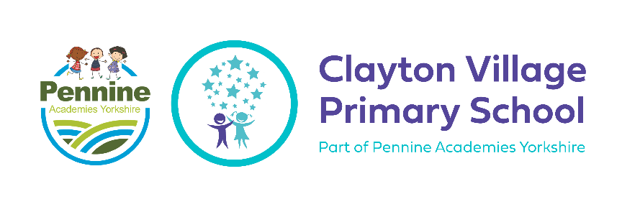

**Music at CVPS**

**Curriculum Intent**

**What do we want to achieve with our Music curriculum?**

The aim of our Music curriculum is to give children at CVPS a love for music. We want to provide a wide and rich musical experience with the opportunity to learn a musical instrument. We want children to have the belief that they *can* sing and that anyone can be a musician. Children will build a bank of knowledge and skills to experiment, invent and create their own musical works of art. Throughout the year we want children to have the opportunities to perform for a variety of audiences and to see live performances.

Key Stage 1 & 2 National Curriculum for Music aims to ensure that all pupils:

* Perform, listen to, review and evaluate music across a range of historical periods, genres, styles and traditions, including the works of the great composers and musicians
* Learn to sing and to use their voices, to create and compose music on their own and with others, have the opportunity to learn a musical instrument, use technology appropriately and have the opportunity to progress to the next level of musical excellence
* Understand and explore how music is created, produced and communicated, including through the inter-related dimensions: pitch, duration, dynamics, tempo, timbre, texture, structure and appropriate musical notations.

**Curriculum Implementation**

**How will this be achieved?**

In Reception, the children will be working on *finding their voice* through singing and listening to each other. In KS1, the children will learn about the many different elements that make up the music we listen to; they will listen to and perform a wide range of music and will learn how to listen with attention and identify different aspects of the music. In KS2, the children will work on reading musical notation, for reading and performing well-known pieces of music and also for writing their own original compositions.

At CVPS music in EYFS and KS1 music has four strands:

**Listening** - listen with concentration and understanding to a range of high-quality live and recorder music.

**Composing** - experiment with, create, select and combine sounds using the inter-related dimensions of music.

**Singing** - use voice expressively and creatively by singing songs, and speaking in chants and rhymes.

**Performing** - play tuned and untuned instruments musically.

At CVPS music in KS2 has six strands:

**Listening** - listen with attention to detail and recall sounds with increasing aural memory.

**Appraising** - Appreciate and understand a wide range of high-quality live and recorded music drawn from different traditions and great composers/ musicians.

**Musical notation** - use and understand staff and other musical notation.

**Musical History** - develop an understanding of the history of music.

**Composing** - improvise and compose music for a range of purposes using the inter-related dimensions of music.

**Singing and performing** - use voice with increasing accuracy, fluency, control and expression. Play instruments musically. Play and perform in solo and ensemble contexts.

**Unit Structure & Lesson Structure**

At CVPS we follow the Charanga Original Scheme for whole class music teaching. We choose one unit a term to ensure coverage of different styles of music from EYFS to Year 6. A scheme has been designed specifically for us at CVPS on Charanga. For the first half term the song will be taught with a singing focus and in the second half term an instrument focus. This is taught by the class teacher in our music room, providing children with a space to be able to express themselves. Each week we aim for children to be taught at least an hour of music. This includes a 30 minutes singing assembly each week along with the whole class ensemble and Charanga. Children will be exposed to different composers/ musicians throughout t

Each week, singing is taught by a music specialist in an assembly for Year 2-6 and in class for Reception and Year 1.

We work with the Music and Arts Service to provide children with the opportunity to learn musical instruments in Year 3 and 4. Year 3 students learn the four different instruments included in samba drumming (agogo bells, ganzas shakers, surdos and tamborims). Year 4 students have the opportunity to learn ukulele with the hope that they will then progress to guitars once they have finished their whole class ensemble teaching.

Each lesson is structured in the same way.

* Listen and appraise
* Warm up
* Singing practise/ musical instrument
* Perform (where appropriate)

**Curriculum Impact**

The impact of teaching and learning of Music will be demonstrated as follows;

* Children will be able to appraise music using key vocabulary and compare it to music they have already heard.
* Children have the confidence and belief that they are able to sing and play at least two musical instruments.
* All children are given the opportunity to be able to perform both in and out of school.

Summative assessment will be used to determine children's understanding and progress throughout a unit and the year. We will record children at the beginning and of the unit and this will be evidenced through Seesaw QR codes in our curriculum BIg Book. In UPKS2, children will begin to write music and this can be used as a form of summative assessment. Formative assessment will also be used when listening to the children's use of vocabulary when they appraise music and how they are playing the instrument in lessons.

All children at CVPS are given an opportunity to perform their musical talent both in and out of school. Performances include;

* Whole school assemblies.
* Performing in front of another class.
* Performing at events for the Windrush celebrations in Bradford.
* Performing at termly choir concerts with local schools/ choirs at the local church.
* Performing at Music and Arts Service events at St Georges Hall.

**Spiral Curriculum**

**Our Aims at CVPS**

Aim High

* Learning a musical instrument (samba drums, ukulele, glockenspiels)
* Opportunity to join the choir from Year 2 to Year 6.
* Singing teacher to lead singing assemblies each week.
* Learning is a change in long term memory and overtime children will be able to play instruments fluently.

Be Respectful

* Develop an understanding and appreciate the history of music.
* Appreciate and understand a wide range of high-quality live and recorded music from different cultures and traditions.
* Collaborating with other schools and community choirs.

Create Happy Memories

* Having the chance to perform within school and in the wider community.
* Recording their own compositions for a CD.
* Exposure to traditional celebrations and the music associated with these. (May Day, National events)
* Watch and listen to live music performances to expose children to a variety styles of music.

**Substantive Knowledge**

**Technical skills & subject knowledge:**

Children gain musical knowledge through learning about a range of musicians, listening and appraising their music, learning how to play music and performing their own music to others. Knowledge in music can be known as tacit knowledge, procedural knowledge and declarative knowledge.

**Tacit Knowledge:** This knowledge gained through experience.

**Procedural Knowledge:** This is shown through the performance of a task.

**Declarative Knowledge:**This refers to facts and information including styles of music and composers.

**Knowledge of Music:**

All musical learning at CVPS is built around the Interrelated Dimensions of Music: pulse, rhythm, pitch, tempo, dynamics, timbre, texture, structure and notation. These dimensions are at the center of all the learning.

As part of reading lessons before a new unit of music is taught, children are exposed to musical knowledge, such as a text on a composer. These lessons act as a tool for pre-learning and support learning into manageable steps - beneficial for previously low attaining/SEND children. More able pupils benefit from working collaboratively - allowing them to articulate their ideas for compositions, share their understanding of the composer's work and apply this style to their own and confidently appraise other performers' music.

**Breadth of study:** in addition to discrete lessons, additional aspects of music are taught through the wider curriculum. All year groups deliver lessons on May Day…

**Developing vocabulary:** our aim is to ensure that our children are familiar with frequently occurring musical words that appear in various contexts and topics (including terms and concepts). These will be identified at the beginning of a unit and then used throughout. Progression of vocabulary is mapped out across the music curriculum to develop children’s understanding and is built upon each year. Previous vocabulary is revisited throughout their music lessons.

**Disciplinary Knowledge**

**Progression:**

We aim for our children to have a deepening awareness of how music is written and played.

**Technical:**

**Constructive:**

**Expressive:**