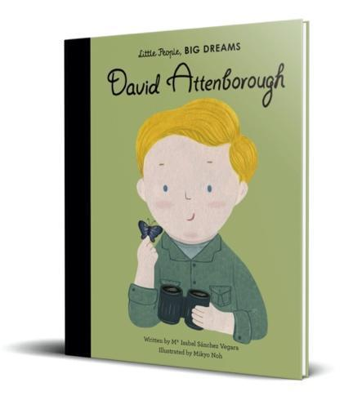David Attenborough Class

Reception Newsletter

Autumn Term



*Family Breakfast Dates:*

**5.9.24 Meet the teacher**

**17.10.24 Black history month**

**21.10.24 Diwali**

*Autumn 2 dates TBC*

For more information, please refer to the school website or MTP.

Important Dates:

Enrichment Week – W/B 23.9.24

History Gallery Showcase – 27.9.24

School Photographs – 1.10.24

Parents evening – 16.10.24

Halloween Disco – 23.10.24*

Break up for half term – 25.10.24

Back to school – 4.11.24

Children in Need – 15.11.24*

No Pens Day – 29.11.24

Panto – 17.12.24*

Christmas Dinner – 18.12.24*

Christmas Disco – 19.12.24*

Break up for Christmas holidays – 20.12.24

**\*voluntary donations**

Uniform and Water Bottles: Please ensure all of the uniform you send your children in is fully named. It makes it much easier for it to be returned to its rightful owner! Your child will require a named pair of wellies and a rain suit as we love to use our outdoor area in all weathers! If it is particularly sunny, a sunhat will be required. Children also need a named water bottle to be filled each day with **only water**. We use Seesaw to send pictures home of children’s work in school. Please see me for a Seesaw code if you do not have one.

Reading at home is vitally important to help your child progress and become a lover of reading. Our library is having a makeover and soon your child will be bringing home a library book to share with you. We will keep you updated on when we will be visiting the library. Group reading will start W/C 23.9.24. The children will take reading books home on Fridays and will need to return them by the following Tuesday. You will need to listen to your child read at least 3 times a week and record in their reading diary each week. This will then be checked by the class teacher.

Our topic this term is called ‘Home is Where the Heart is’. We will be focusing on fiction and non-fiction books including, Goldilocks, The Three Little Pigs, This is My Home, We are Family and many more! This theme helps support children develop a sense of community as a class, as part of our school family and of their local area – Clayton. We will be exploring past and present homes in our community. A lot of the first half-term is spent making sure children are settling into CVPS and learning the expectations and routines of school.

Welcome to school from your class teacher Miss Robinson and your teaching assistants Miss Harrison and Miss Stokes. We are delighted to welcome the children to Clayton Village Primary School, where they have all had a great start to the year! We are extremely impressed with how the children have started Reception. They have already started to learn many of the reception routines and began to make new friends.

If you have any questions, please do not hesitate to contact a member of the Reception team.