History  Remembrance – Moina Michael - the poppy lady  When did Bradford become a city?  What is living memory?  Knowledge:  - To understand where in the world and when in the past we are learning about. To understand chronological duration. Create a model village (link with science what we need for a healthy life).  - Significant local event. | Science  Plants – How can I look after the plants in our garden?  Knowledge:  - Find out and describe how plants need water, light and a suitable temperature to grow and stay healthy.  - Use the local environment throughout the year to observe how plants grow.  - Observe and describe how seeds grow into mature plants.  - Describe how animals and plants get what they need to survive from their habitat.  - Say if something is living, dead or never been alive.  Animals including Humans – How can I look after myself?  Knowledge:  - Talk about and describe how to look after themselves  - Look after their own health  - Talk about how to look after a pet.  - Describe how animals help humans. | Geography  What does Bradford look like on a map?  Knowledge:  - Use world maps, atlases and globes to identify the United Kingdom and its countries, as well as the countries, continents and oceans studied at this key stage  - Use aerial photographs and plan perspectives to recognise landmarks and basic human and physical features; devise a simple map; and use and construct basic symbols in a key  - Use basic geographical vocabulary
Computing  Programing - Knock Knock Joke  - Understand what algorithms are; how they are implemented as programs on digital devices.  - Create and debug simple programs  - Use logical reasoning to predict the behaviour of simple programs | Emmeline Pankhurst  Autumn Curriculum | R.E  Why do we need to give thanks?  - Hinduism, Christianity, Humanist
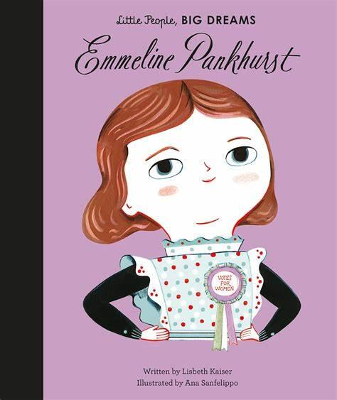  PSHE  Living in the Wider World  - Understand what is money, Understand how we pay for things, Understand why people save their money  Health and Wellbeing  - Understand healthy habits, Explain why sleep routines are important, Learn about BIG feelings and how we manage them. |  | P.E  Invasion Game - Rugby  - Agility, hand-eye coordination, kicking, running, throwing, catching  Gymnastics  - Shapes, balance, flexibility, sequences, rolls
Art  Drawing  Painting  Artist: David Hockney  Formal Element: Line, Shape, Pattern  - Confidently use charcoal, pencil and pastels  - Choose colours and mix paint to express a particular mood in artwork  - Use key vocabulary to demonstrate knowledge and understanding in this strand: collage, squares, gaps, mosaic, features, cut, place, arrange | Design Technology  Mechanisms - Moving Monsters  - Design, make and evaluate  - Design purposeful, functional, appealing products for themselves and other users based on design criteria.  - Select from and use a range of tools and equipment to perform practical tasks.  - Evaluate their ideas and products against design criteria. | Music  Hands, Feet, Heart  - Listen and appraise  - Performance

