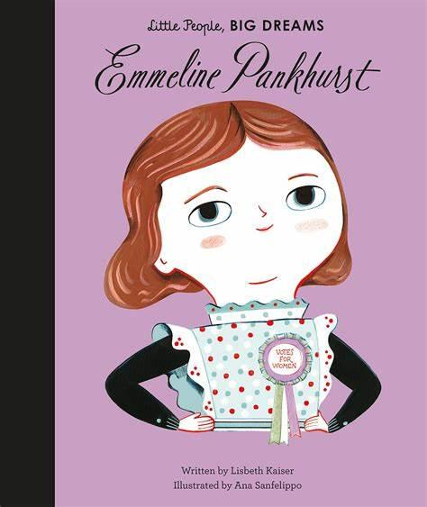

**Autumn Curriculum**

Our topic for this term is ‘**Adventures in the City.’** We will be learning about the history of our city. This will include when Bradford became a city, what it looks like on a map, and how it has changed over the last 100 years. Also, we focus on some important individuals and their lives in the history of Clayton and the city of Bradford. One person we focus on during our art topic is David Hockney and how his art styles have had an influence on the city. You could continue learning at home by researching the city of Bradford and how it has changed e.g. looking at old pictures and learning about the lives of significant people.

**For more information, please see the school website.**

**Year 2 – Emmeline Pankhurst**

Welcome from your class teacher, **Mrs Haxby** and your teaching assistant, **Mrs Roddis**. We are so excited to welcome the children back to CVPS and we can’t wait to watch them progress in Year 2. Our class name is Emmeline Pankhurst and we will be learning about why she is an important figure this half-term.

**Important Dates**

School Photographs – 1.10.24

Parents evening – 16.10.24

Halloween Disco – 23.10.24*

Break up for half term – 25.10.24

Back to school – 4.11.24

Children in Need – 15.11.24*

No Pens Day – 29.11.24

Road Safety – 6.12.24

Panto – 17.12.24*

Christmas Dinner – 18.12.24*

Christmas Disco – 19.12.24*

Break up for Christmas holidays – 20.12.24

*voluntary donations

**Family Breakfast Dates**

**05.09.24 –** Meet the Teacher

**26.09.24 –** Commando Joe

**17.10.24 –** Black History Month

**26.10.24** – Diwali

**Autumn 2 dates tbc**

.

**Water Bottles**

Children are encouraged to bring water bottles to school as it is important that we are hydrated so we can work and be focused fully. Children are not to bring water bottles with spray functions on them.

**PE**

Our PE is on a **Monday** this year. Please come to school dressed in your full kit: black jogging bottoms and hoody top with a house colour t-shirt. Make sure that your water bottle is brought in and full especially on PE days.

**Personal belongings**

Children can bring a bag to school to bring home letters, uniform and other important pieces of information. We ask that all personal belongings remain at home. Children do not need to bring any equipment from home. However, they must bring their bag with them every Tuesday and Friday to have their book changed.

Please **name** label absolutely everything your child brings to school including their **lunch box** (if they bring one).

**Coats and jumpers** are regularly taken on and off and will usually be returned if clearly named.

**Reading**

At Clayton Village, we want all children to be readers and it is a value we encourage. Not only for academics but more for joy and escapism from the everyday world.

Children should read at home at least 3 times a week. Please record this in your child’s Reading Record.

Your child will bring their new reading book home on a Thursday and must return it to school the next Tuesday.

We will be visiting the library every week so your child will have another opportunity to select a book.

Autumn Term 2024