

**PE**

Our PE is on a **Thursday**. Please come to school dressed in your full kit: black jogging bottoms, black hoody and house colour t-shirt. All clothing should be plain with no patterns or large logos.

Autumn Term 2024

**Important Dates**

Gallery Showcase – 27.09.24

School Photographs – 01.10.24

Census Day – 3.10.24

School Election Day – 4.10.24

Parents evening – 16.10.24

Halloween Disco – 23.10.24*

Break up for half term – 25.10.24

Back to school – 04.11.24

Children in Need – 15.11.24*

No Pens Day – 29.11.24

Road Safety – 06.12.24

Christmas Panto – 17.12.24*

Christmas Dinner – 18.12.24*

Christmas Disco – 19.12.24*

Break up for Christmas holidays – 20.12.24

**\*voluntary donations**

**Autumn Curriculum**

In Autumn, the whole school is studying a local area in history and geography. We will be studying historical concepts of Bradford. We will be looking at how Bradford changed because of the Industrial Revolution.

In Science, we will be studying living things and their habitats and animals including humans. We will then move onto looking to answer the question, why do our teeth fall out? We will identify different types of teeth in humans and their functions. We will also research the basic parts and functions of the digestive system and how to keep it healthy.

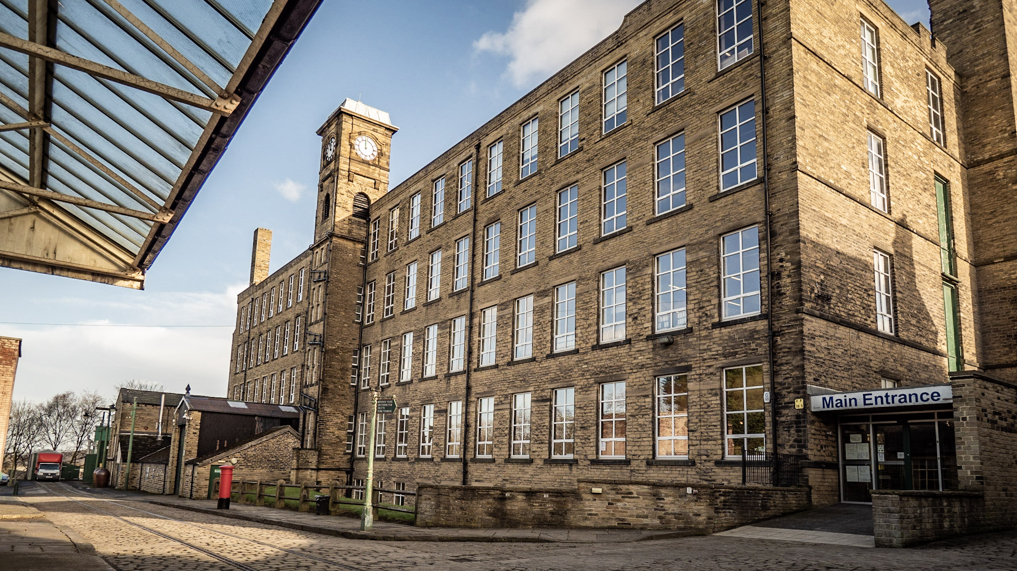

**Times Tables**

By the end of Year 4, children are expected to learn their times tables off by heart up to 12x. In June, the children will be completing a Multiplication Check where they will be tested on their times table knowledge.

Throughout the year, we will be working in hard in class to practise. Alongside this, children should be practising at home on Emile. Activities will be set on Emile regularly.

**Reading**

At Clayton Village, we want all children to be readers and it is a value we encourage. Not only for academics but more for joy and escapism from the everyday world.

Children in Year 4 should read at **least 3 times a week.** They do not need to read aloud to an adult but you are encouraged to ask your child questions about what they have read. We will have a weekly timetabled ‘Book Talk’ session where children and staff can share and recommend their favourite books. We will also have a daily DEAR (drop everything and read) session where children can enjoy their reading book.

We will be visiting the library fortnightly so your child will have another opportunity to select a book.

**Mr Devanney and Miss Corriette**

Year 4- Greta Thunberg

Welcome back! I hope you had a fun, relaxing Summer and are ready to come back learning.

Visit the School Website for this term’s medium term plan and updates of our learning. We also have our twitter page!

**Water Bottles** Children are encouraged to bring water bottles to school, as it is important that we are hydrated so we can work and be focused fully. Children are not to bring water bottles with spray functions on them.

These will be stored by the sink and children will be encouraged to drink these throughout the day. If a child requires a drink during a lesson, it is the teacher’s discretion to find a suitable time. Make sure that your water bottle is brought in everyday.

**Family Breakfast Dates**

**05.09.24 –** Meet the Teacher

**26.09.24 –** Commando Joe

**17.10.24 –** Black History Month

**24.10.24** – Diwali

**Autumn 2 dates tbc**