History  What were the consequences of the industrial Revolution in Bradford?  Knowledge:  - A local history study over time tracing how several aspects of national history are reflected in the locality. | Science  Living Things and their Habitats- What is the circle of life?  Knowledge:  - Describe the sexual reproduction of plants  - Describe the asexual reproduction of plants  - Explain the difference between asexual and sexual reproduction in plants  - Describe the differences in the life cycles of a mammal, an amphibian, an insect and a bird  - Describe the life process of reproduction in some plants and animals  Animals Including Humans - What is the circle of life?  Knowledge:  - Describe the changes of humans from birth to death  - Name and order the different stages of human life e.g. foetus, baby, child, adolescent, adult, old age  - Describe how a baby changes physically as it grows and what it is able to do  - Describe the changes as humans develop to old age |  | Geography  How do settlements in the UK vary?  Knowledge:  - Name and locate counties and cities of the United Kingdom, geographical regions and their identifying human and physical characteristics, key topographical features (including hills, mountains, coasts and rivers), and land-use patterns; look at the wool trade and how trade has changed.  - Describe and understand key aspects of physical geography, including: climate zones, biomes and vegetation belts, rivers, mountains, volcanoes and earthquakes, and the water cycle  - Describe and understand key aspects of human geography, including: types of settlement and land use, economic activity including trade links, and the distribution of natural resources including energy, food, minerals and water
Computing  Programming- quizzes in scratch  - design, write and debug programs that accomplish specific goals, including controlling or simulating physical systems; solve problems by decomposing them into smaller parts  - use sequence, selection, and repetition in programs; work with variables and various forms of input and output  - use logical reasoning to explain how some simple algorithms work and to detect and correct errors in algorithms and programs  E-safety  - Understand the terms plagiarism and copyright and be aware of the implications of copying and sharing content without permission. | Ada Lovelace  Autumn Curriculum  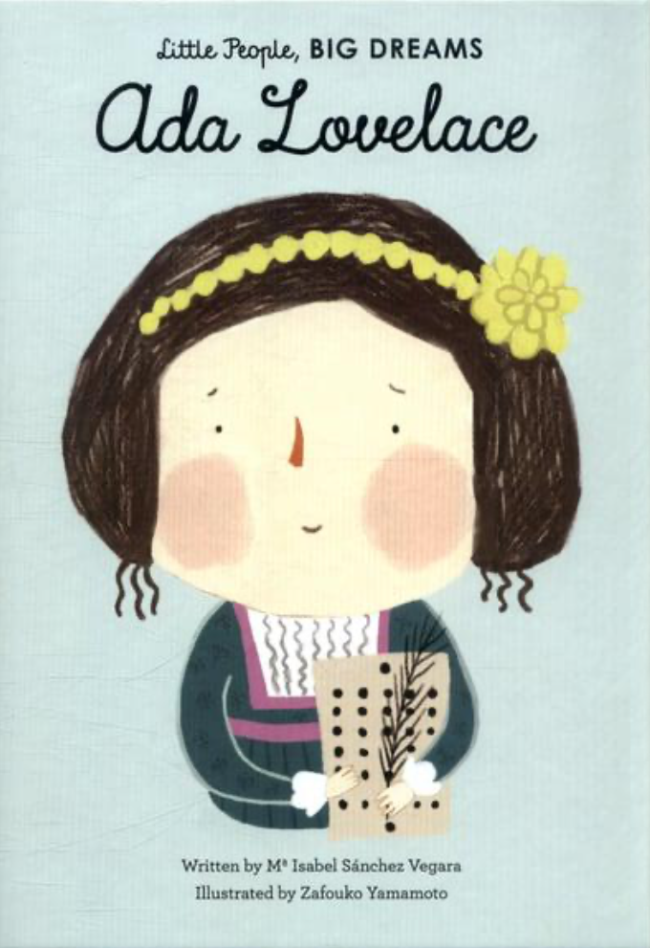 |  | R.E  Why do people have to stand up for what they believe in?  - To explore why people from the same religion may disagree.  - To consider the thoughts, feelings, experiences, beliefs and values of others.  - To make links and comparisons between world views about belonging, meaning, purpose and truth.  - To express ideas about fairness, honesty, love, forgiveness, truth and peace.
PSHE  Living in the Wider World:  - Internet and screen time, Age restrictions, Careers and stereotypes, Fake news, Fireworks and bonfires  Health and Wellbeing:  - Understanding emotions, Feelings, emotions and vocabulary , self-esteem, what is mental health?, Physical health and FGM introduction |  |  | P.E  Invasion - Football  - Special awareness, ball control, attack and defence, decision making.  Gymnastics  - Shapes, movement, balance, flexibility, body tension, sequences, rolls.  - Link skills to make actions and sequences of movement.  - Combine and perform gymnastic actions, shapes and balances more fluently and effectively.
Art  David Hockney  Drawing, Painting & Printmaking  Formal element: Line, shape, texture  - Make our own printing block using lino, ink it up using a roller and make a print.  - Understand that prints come out in reverse.  - Explore David Hockney’s connections to Bradford and associated artworks. | Design Technology  Food and nutrition - What could be healthier?  - Understand and apply the principles of a healthy and varied diet  - Prepare and cook a variety of predominantly savoury dishes using a range of cooking techniques  - Understand seasonality, and know where and how a variety of ingredients are grown, reared, caught and processed. | Music  Living on a Prayer  - Listen and appraise  - Performance  Ukelele | MFL  French Monster Pets  Shopping in France  - Listen attentively to spoken language and show understanding by joining in and responding.  - Explore the patterns and sounds of language through sound and meaning of words.  - Engage in conversations; ask and answer questions; express opinions and respond to those of others; seek clarification and help.

