History  Who were the Bronte family?  What impact did railways have on Haworth?  - A local history study over time tracing how several aspects of national history are reflected in the locality. | Science  Living things and their habitats – How and why do we classify animals?  - Describe how living things are classified into broad groups according to common observable characteristics and based on similarities and differences, including micro-organisms, plants and animals  - Give reasons for classifying plants and animals based on specific characteristics  Animals including Humans – How can I ensure my heart lasts a lifetime?  - Identify and name the main parts of the human circulatory system, and describe the functions of the heart, blood vessels and blood  - Recognise the impact of diet, exercise, drugs and lifestyle on the way their bodies function  - Describe the ways in which nutrients and water are transported within animals, including humans |  | Geography  Why do people climb Ben Nevis?  - Name and locate counties and cities of the United Kingdom, geographical regions and their identifying human and physical characteristics, key topographical features (including hills, mountains, coasts and rivers), and land-use patterns; and understand how some of these aspects have changed over time  - Describe and understand key aspects of: physical geography, including: climate zones, biomes and vegetation belts, rivers, mountains, volcanoes and earthquakes, and the water cycle
Computing  Programming- Microbit sensors  - I can decompose a design or code to focus on specific parts  - I can critically evaluate my work and suggest improvements  - I can identify the need for, and work with, variables  - I can use a range of sequence, selection and repetition commands to implement my design | Ernest Shackleton  Autumn Curriculum  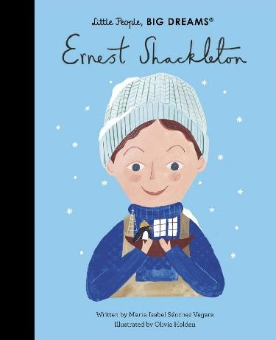 |  | R.E  Why does religion look different around the world?  Judaism, Islam, Christianity
PSHE  Health and Wellbeing  - Understand how to maintain a healthy lifestyle. Including a balanced diet, water intake and sleep.  Relationships Education  - Positive relationships, Disagreeing respectfully, family and commitment, online gaming safety. |  |  | P.E  Invasion game – Rugby  - Use running, throwing and catching in isolation and in combination  - invade the opponent's territory or zone to score goals or points; protect your own territory to prevent the opposition from scoring goals or points.  - Play competitive games, modified where appropriate  Gymnastics  - Develop flexibility, strength, technique, control and balance  - compare their performances with previous ones and demonstrate improvement to achieve their personal best
Art  Drawing  Painting  Textiles  Artist: Paul Nash  Formal Element: Texture, colour, tone  - Observe the Landscape - Use contemporary WW1 era photos to make observational drawings of the wartime landscape.  - Use images taken from the trip to Haworth to stylize paintings of the Yorkshire landscape in the style of  Paul Nash.  - Make felt poppies | Design Technology  Structures – Playground Structures  - Use research and develop design criteria to inform the design of innovative, functional, appealing products that are fit for purpose, aimed at particular individuals or groups.  - Select from and use a wider range of tools and equipment to perform practical tasks accurately.  - Evaluate their ideas and products against their own design criteria and consider the views of others to improve their work.  - Apply their understanding of how to strengthen, stiffen and reinforce more complex structures. | Music  Happy  - Listen and appraise  - Performance | MFL  French Sport and the Olympics  In My French House  - Engage in conversations; ask and answer questions; express opinions and respond to those of others; seek clarification and help.  - Speak in sentences, using familiar vocabulary, phrases and basic language structures.  - Develop accurate pronunciation and intonation so that others understand when they are reading aloud or using familiar words and phrases.  - Present ideas and information orally to a range of audiences.  - Write phrases from memory, and adapt these to create new sentences to express ideas clearly.  - Use familiar vocabulary in phrases and simple writing.  - Describe people, places and things and actions orally and in writing.

