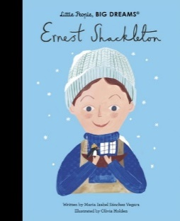

**PE**

Our PE is on a Wednesday. Please come to school dressed in your full kit: black jogging bottoms, black hoody and house colour t-shirt. All clothing should be plain with no patterns or large logos.

**School Trips**

We are very excited for our school trip to Haworth on the 20th September, 2024 to learn more about the Bronte Family and their significance in our local history.

We are also busy organising a theatre trip for the Summer Term. Keep a look out for further announcements.

**Water Bottles** Children are encouraged to bring water bottles to school as it is important that we are hydrated so we can work and be focused fully. Children are not to bring water bottles with spray functions on them. Make sure that your water bottle is brought in and full especially on PE days.

**Important Dates**

Haworth School Trip – 20.09.24

History Gallery Showcase – 27.09.24

School Photographs – 01.10.24

Census Day – 3.10.24

School Election Day – 4.10.24

Parents evening – 16.10.24

Halloween Disco – 23.10.24*

Break up for half term – 25.10.24

Back to school – 04.11.24



**Important Dates**

Children in Need – 15.11.24*

No Pens Day – 29.11.24

Road Safety – 06.12.24

Christmas Panto – 17.12.24*

Christmas Dinner – 18.12.24*

Christmas Disco – 19.12.24*

Break up for Christmas holidays – 20.12.24

**\*Voluntary donations**



**Reading**

At Clayton Village, we want all children to be readers and it is a value we encourage. Not only for academics but more for joy and escapism from the everyday world.

We encourage all of our children to become avid readers and read at home frequently. They do not need to read aloud to an adult but you are encouraged to ask your child questions about what they have read. This year, to encourage reading your child has been provided with a reading journal: it is for them to present reflections/ reviews on the book they have been reading.

We will also be visiting the newly revamped library fortnightly so your child will have another opportunity to select a book.



**Mrs Hickey and Miss Binder**

Year 6- Ernest Shackleton

Welcome back to another term in Year 6! We hope you had a lovely summer break and are ready for lots of new and exciting learning.

Miss Binder will be your teacher on Monday and Tuesday, Mrs Hickey will be your teacher on Wednesday, Thursday and Friday.

Visit the School Website for this term’s medium term plan and updates of our learning.

Autumn Term 2024

**Autumn Curriculum**

In Autumn, Year 6 will be studying Haworth and the understanding historic value of this Yorkshire village. They will learn who the Bronte family were and the importance of the railways, making links to the industrial revolution. Within art, they will study Paul Nash and use techniques created by the artist to paint their own landscapes based on photos taken in Haworth. We will also be

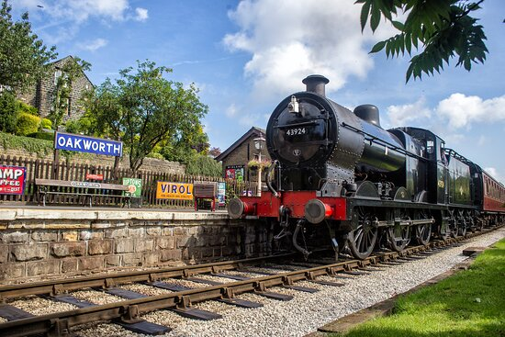

In Science, we will be studying living things and their habitats and looking to answer the question, how and why do we classify living things? We will also be understanding the importance of looking after our bodies and finding out how we can ensure our heart lasts a lifetime. This will include exploring the human circulatory system and how diet and excerise can effect this.