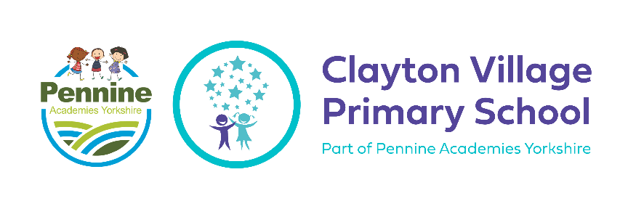

**PSHE at CVPS**

**Curriculum Intent**

**What do we want to achieve with our PSHE curriculum?**

The aim of our PSHE curriculum is to give children at CVPS the opportunity to become healthy, independent and responsible members of society. PSHE is taught at CVPS so that children can understand their own health and wellbeing, living in the wider world and building positive relationships. Our PSHE lessons are accessible to all and aim to help our pupils know more, remember more and understand how to play a positive role in our society.

**Curriculum Implementation**

**How will this be achieved?**

Our PSHE Curriculum has been planned to suit the children we have in our school and relevant topics happening in our world currently. As part of our PSHE curriculum, we start the year with a questionnaire for each child that covers statements about our curriculum. From these results we then build the curriculum to be personal and suitable to each class and individual child. The progression of PSHE skills, knowledge and understanding are divided into the following areas of learning:

* Health and Wellbeing
* Living in the Wider World
* Relationships Education.

Each of these areas of learning are revisited during each new unit of work, building on prior learning and effectively developing the skills, knowledge and understanding to become a well-rounded member of society. Our PSHE curriculum, provides pupils with a knowledge of their world, locally, nationally and globally and gives them the confidence to tackle many of the moral, social and cultural issues that are part of growing up within this. Our intention is to provide our pupils with opportunities for them to learn about rights and responsibilities and appreciate what it means to be a member of a diverse society.

**Unit Structure & Lesson Structure**

Each year group will cover the three main areas of PSHE, health and wellbeing, living in the wider world and relationships education. Children will receive one lesson per week which builds across the year and also then as they move up to the next year groups. The PSHE lead will plan how this is covered during the term, by creating MTP to ensure coverage. This will be communicated and agreed with the class teachers prior to the commencement of the new term.

Throughout the units of PSHE, children will: be taught to develop their communication skills, problem solving skills and understanding their own thoughts and feelings. Class teachers will carefully plan for the use of visits and visitors to complement and enhance the teaching of PSHE. Commando Joes is also an extension of our PSHE curriculum and children will use the RESPECT framework in our PSHE lessons.

**Curriculum Impact**

The impact of the teaching and learning of PSHE will be demonstrated as follows:

* Pupils will be able to speak about their own thoughts and feelings.
* Pupils will have an understanding of being mentally and physically healthy.
* Pupils will develop their sense of self-worth and play a positive role in contributing to school life and the wider community.
* Pupils will strive to become respectful and responsible lifelong learners who are determined to achieve their best.

Formative Assessment will be used to determine children’s understanding and this will be summarised at the end of each term to inform the class teacher and PSHE Subject Leader of the numbers of pupils working below, at and above age-related expectations. The completed summary will be shared by the class teacher. To make these assessments, class teachers will use the assessment questionnaire and listening to children during lessons.

**Spiral Curriculum**

The PSHE curriculum design follows the spiral curriculum model by Jerome Bruner in which key concepts are presented repeatedly throughout the curriculum, but with deepening layers of complexity, or in different applications. Throughout the teaching of PSHE, pupils will build a deeper understanding of the three main areas;

* Health and Wellbeing
* Living in the Wider World
* Relationships Education

**Our Aims at CVPS**

Our PSHE curriculum also relates to our aims at CVPS and these will be referred to during the lessons;

* Aim High
* Be Respectful
* Create Happy Memories

**Substantive Knowledge**

Health and Wellbeing

* Includes self-esteem and confidence, mental and physical health, drugs and alcohol education and first aid.

Living in the Wider World

* Includes understanding my place in class, school and global community also learning about inclusion and diversity.

Relationships Education

* Includes understanding friendships, family and other relationships.

**Disciplinary Knowledge**

* Pupils gain awareness of the activity in their minds, relaxing them and quietening their thoughts and emotions to a place of optimum learning capacity.
* Pupils develop the ability to take enjoyment from their learning, be an inclusive learner and build social skills
* Pupils to improve their concentration and learning by filtering out activity and distractions around them.
* Pupils are encouraged to introduce new information, concepts and skills, using a range of approaches and activities.
* Pupils to develop the ability to manipulate, use and play with new information in order for it to make sense to them and for them to ‘accommodate’ it into their existing learning.