David Attenborough Class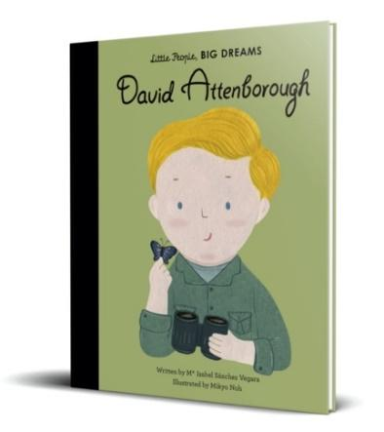

Reception Newsletter

Miss Robinson

Miss Harrison, Miss Stokes and Mrs Mitchel

Spring Term 2025

