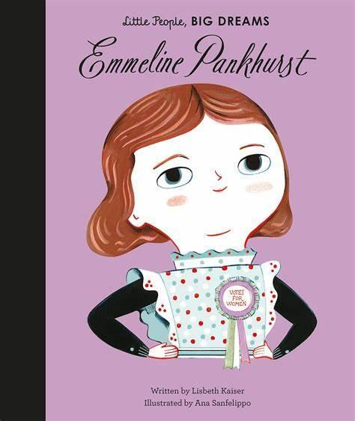

**Spring Curriculum**

Throughout this term, Year 2 will be exploring some of the countries, animals, and plants that we find on each continent! Year 2 will learn how to use maps to find different places in the world. This will help them to understand where in the world they are compared to the places and people we learn about. You could continue this at home by showing your children where their houses are on a map. We will also be exploring what it is like to live at the coast in preparation for our trip to the beach in Summer!

As part of our history topic, we will be focusing on the Wright brothers, who created the world’s first successful motor-operated airplane! We will also investigate the impact this has had on history for example the use of modern planes to go on holiday or delivering packages across the world. This links to our science investigation surrounding materials as we find out what material is best to make a plane fly!

**For more information, please see the school website for the Medium Term Plan.**

**Water Bottles**

Children are encouraged to bring water bottles to school as it is important that we are hydrated so we can work and be focused fully. Children are not to bring water bottles with spray functions on them.

**INPP School Programme**

Year 2 will be taking part in a developmental program which compromises of a series of exercises based on movements to support balance and posture.