History  Vikings: How did the power of regions change during the Dark Ages?  What was life in Anglo-Saxon England like?  Is it fair to describe the Vikings as vicious raiders?  Does Alfred deserve to be known as The Great?  Knowledge:  - The Viking and Anglo-Saxon struggle for the Kingdom of England, resistance by Alfred the Great and Athelstan, the first king of England. | Science  Forces – Why can’t we walk on the ceiling?  Knowledge:  - Explain that unsupported objects fall towards the Earth because of the force of gravity acting between the Earth and the falling object  - Identify and explain the effects of water resistance  - Explain how a lever and a pulley works  - Explain that levers and pulleys allow a smaller force to have a greater effect  - Explain that weight is a force  - Explain that gravity is a force  - Explain the Moon is many times smaller than the Moon so gravity on the Moon is very much smaller than on the Earth.  - Explain why there is no atmosphere on the Moon so no air resistance. If they are released at the same instant, both the heavy object and the very light object reach the ground at the same time.  Scientific Enquiries:  - Why does the Moon not fall out of the sky? (pattern seeking)  Properties and Materials – Can I clean my dirty water?  - Describe the properties of objects  - Compare and group everyday objects based on their properties  - Explain what dissolving means and give examples  - Explain what filtering and sieving are and give examples  - Explain how materials can be recovered from solutions or mixtures through evaporation, filtering and sieving.  - Describe reversible and non-reversible changes including examples. E.g. burning wood, rusting, mixing vinegar and bicarbonate of soda  Scientific Enquiries:  - How did a Viking boat make it to Britain? (Comparative and fair testing)  - How can we clean dirty water? (Comparative and fair testing) |  | Geography  How has Norway become the most sustainable country in the world?  Knowledge:  - Name and locate counties and cities of Scandinavia, geographical regions and their human and physical characteristics, key topographical features (including hills, mountains, coasts and rivers), and land-use patterns; look at the wool trade and how trade has changed.
Computing  Sound- 4 chord remix  Sound:  - Know how to create a simple four chord song following the correct rhythm.  - Know how to create a remix of a popular song.  Computational thinking:  - Know how to solve problems by decomposing them into smaller parts  - Know how to critically evaluate my work and suggest improvements | Ada Lovelace  Spring Curriculum  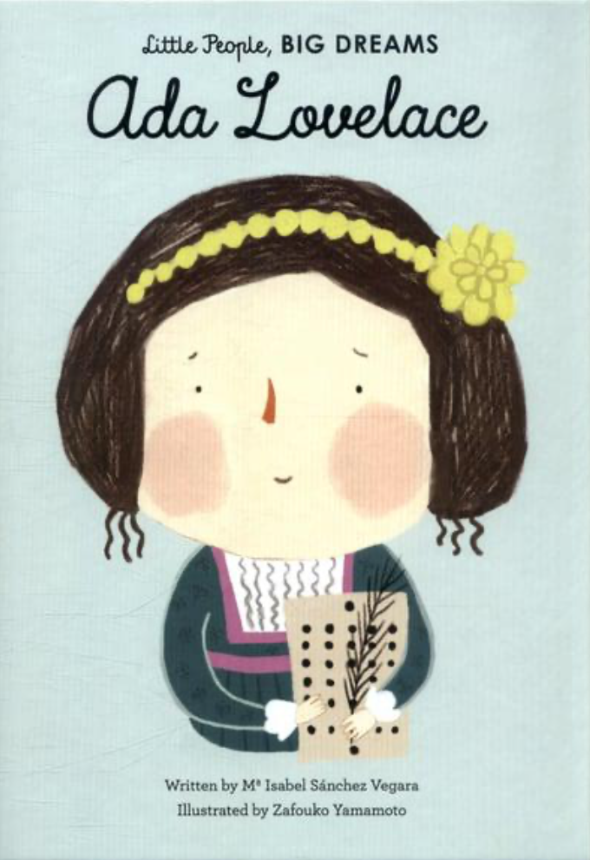 |  | R.E  What happens when we die (part 1)?  Religions: Christianity, Islam, Hinduism
PSHE  Relationships Education  - Caring for Babies  - Gender Identity & LGBTQ+ Introduction  - Online Behaviour & Risks  - Stranger Danger  Living in the Wider World  - Success & Achievement  - Independence & responsibility  - Courtesy & Manners  - Change, Grief & Loss  - The Environment & Climate Change |  |  | P.E  Invasion game - Handball  - Special awareness, ball control, attack and defence, decision making.  Dance  - Shapes, movement, balance, flexibility, body tension, sequences, rolls.
Art  Artist: Chris Kenny  Drawing  Painting  Textiles  Formal Element: Line, shape, tone, pattern, colour  - Use different tools to apply paint.  - Produce increasingly accurate drawings.  - Explore Chris Kenny’s work and build up relief sculptures from maps of Britain or the local area. | Design Technology  Mechanical Systems - Automata Toys  - Use research and design products fit for purpose.  - Use a wide range of tools and equipment to perform tasks.  - Evaluate ideas and products against their design. | Music  Make You Feel My Love  - Listen and appraise  - Perform | MFL  Verbs in a Week  - Engage in conversations; ask and answer questions; express opinions and respond to those of others; seek clarification and help.  - Speak in sentences, using familiar vocabulary, phrases and basic language structures.  - Develop accurate pronunciation and intonation so that others understand when they are reading aloud or using familiar words and phrases.  - Present ideas and information orally to a range of audiences.  - Write phrases from memory, and adapt these to create new sentences to express ideas clearly.  - Use familiar vocabulary in phrases and simple writing.

