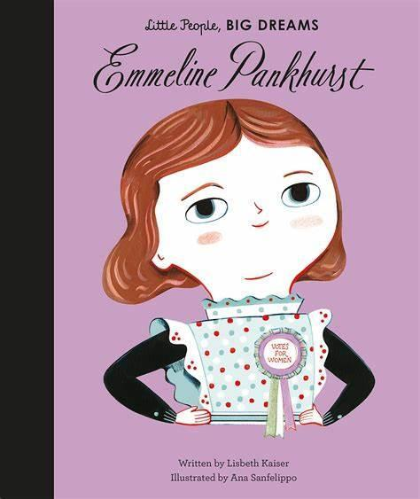
Year 2 – Emmeline Pankhurst
Welcome back, we hope you are well rested and ready for the Summer term.

Mrs Cooper & Mrs Roddis

Reading
Reading books will continue to be handed out on Wednesdayss and need to be returned Mondays Please log your child’s reading in their reading record and read at least three times per week.

Year 2 will visit the library every other week. Your child will be able to bring a new book home provided they have returned their previous one.

Important Dates

01.05.26 – CVPS May Day
04.05.26 – Bank Holiday Monday (school closed)
21.05.26 – CVPS Wellbeing Day
22.05.26 – End of half-term
08.06.26 – School re-opens
10.06.26 – Year 1 Phonics Screening Check
18.06.26 – Father’s Day shop
20.07.26 – CVPS Sports Day
23.07.26 – Break up for Summer

PE
PE continues to be on a Wednesday. Please come to school dressed in your full kit: black jogging bottoms and hoody top with a house colour t-shirt. As we will be aiming to do PE lessons outside you may wish to send your child in with sun cream on. Please make sure that your water bottle is brought in and full especially on PE days.
Water Bottles
Children are encouraged to bring water bottles to school as it is important that we are hydrated so we can work and be focused fully. Children are not to bring water bottles with spray functions on them.
Summer Curriculum
Across the term, we will be exploring different areas of the world and researching significant individuals throughout history.
Over this term Year 2 will be learning about how Bradford is different to other places in the world. This will include a focus on places in our country and places on other continents. We will also be completing some fieldwork during our visit to Filey as an extension of our coastline topic last term.
As part of our history topic, we will be focusing on Grace Darling and researching why she was important. Furthermore, we will discover the impact she has had on history and why we remember her. We will explore the history of seaside holidays and how they have changed in the last 100 years. Our trip to the beach will be a perfect fit to this topic!
Year 2 will also be learning about animals and how they grow over time, this will include exploring life cycles and finding out how certain animals survive in their habitats.
For more information, please see the school website for our Y2 Medium-Term Plan.

Family Breakfast

Summer Term 2025
Personal belongings
Please ensure children do not bring in personal belongings.
Please name label absolutely everything your child brings to school including their lunch box (if they bring one).
Coats and jumpers are regularly taken on and off and will usually be returned if clearly named.

Filey Trip
We are looking forward to our trip to the seaside on Thursday 5th June 2025. Please ensure the children are in school for 7:30am and are collected at 4:30pm unless otherwise stated on Ping. Don’t forget your donation of £2 if your child would like an ice cream and their disposable packed lunch if that is what you stated. The children are allowed to wear non-uniform on the day of the trip but please send children with a purple school jumper and suitable footwear for walking to the beach.

