History  What is a monarch?  - Recall that a monarch is a king or queen.  - Identify some of the monarch’s roles.  - Explain that a king or queen is crowned in a special ceremony called a coronation.  - Name some of the main steps in the coronation ceremony.  - Use sources to explain how William the Conqueror became King of England.  - Explain how William the Conqueror kept order and conquered England.  - Explain how castles have changed over time.  - Identify that the power of monarchs has changed over time.  - Make comparisons between past and present monarchies. | Science  Living things and their habitats - Habitats around the world  Knowledge:  - Talk about how to look after a pet  - Describe how animals help humans.  - Talk about baby animals and their parents.  - Describe how baby animals change as they grow. Notice that animals have offspring which grow into adults.  - Compare baby animals with their parents and other baby animals.  - Find out about and describe the basic needs of animals, including humans, for survival (water, food and air).  - Describe the importance for humans of exercise, balanced diets, and hygiene.  Scientific Enquiries:  - How does a shark survive in the ocean?  - How do animals grow over time? (observing over time)  Uses of Everyday Materials  Knowledge:  - Find out and describe how plants need water, light and a suitable temperature to grow and stay healthy.  - Use the local environment throughout the year to observe how plants grow.  - Observe and describe how seeds grow into mature plants.  Scientific Enquiries:  - What does a plant need to grow and stay alive?  - Growing sunflowers (observing over time) | Geography  What is it like to live by the coast?  Knowledge:  - Name and locate the seas and oceans surrounding the UK in an atlas.  - Label these on a map of the UK.  - Describe the location of the seas and oceans surrounding the UK using compass points.  - Define what the coast is.  - Locate coasts in the UK.  - Name some of the physical features of coasts.  - Explain the location of UK coasts using the four compass directions.  - Name features of coasts and label these on a photograph.  - Identify human features in a coastal town.  - Describe how people use the coast.  - Follow a prepared route on a map.  - Identify human features on the local coast.  - Record data using a tally chart.  - Represent data in a pictogram.  - Describe how the local coast has been used.
Computing  Artificial intelligence – video creation & presentations  - Use technology purposefully to create, organize, store, manipulate and retrieve digital content.  - Recognise common uses of information technology beyond school.  - Use Artificial intelligence to create videos and presentations. | Emmeline Pankhurst  Summer Curriculum  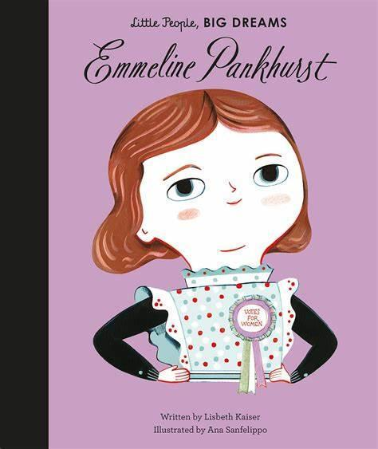 | R.E  How and why do some people pray?
PSHE  Story project  The girl at the front of the class  - I can tell you what a refugee is  - I can tell you what human rights are  - I can tell you how I understand the needs of others  - I can tell you how I support others  - I can tell you some strategies for deciding if someone is trustworthy  Grandads camper  - I can tell you some of the feelings associated with times of change and loss.  - I can tell you some strategies I have for dealing with times of change and loss.  - I can tell you how I could get help if I or someone I care about was struggling with times of change or loss.  - I can tell you about some of the different relationships I have with people in my family and why they are important.  - I can tell you how helping others helps make me happy. |  | P.E  Rounders  - Agility, hand-eye coordination, batting, running  Athletics  - Master basic movements including running, jumping, throwing and catching, as well as developing balance, agility and co-ordination.
Art  Monochromatic  produce creative work, exploring their ideas and recording their experiences  • become proficient in drawing, painting, sculpture and other art, craft and design techniques  • evaluate and analyse creative works using the language of art, craft and design  • know about great artists, craft makers and designers, and understand the historical and cultural development  of their art forms  • use a range of materials creatively to design and make products  • use drawing, painting and sculpture to develop and share their ideas, experiences and imagination  • develop a wide range of art and design techniques in using colour, pattern, texture, line, shape, form and space  • learn about the work of a range of artists, craft makers and designers, describing the differences and  similarities between different practices and disciplines, and making links to their own work | Design Technology  Cooking and Nutrition - a balanced diet.  - Design, make and evaluate.  - Design purposeful, functional, appealing products for themselves and other users based on design criteria.  - Select from and use a range of tools and equipment to perform practical tasks.  - Select from and use a wide range of ingredients  - Evaluate their ideas and products against design criteria. | Music  Friendship Song  - Listen and appraise  - Performance

