History  What was important to ancient Egyptians?  - Identify where and when ancient civilisations first appeared.  - Ask historically valid questions about sources.  - Identify Ancient Egypt’s location and its key geographical features.  - Explain why the River Nile was important to ancient Egyptians.  - Explain the significance of the Rosetta Stone.  - Explain the importance of gods and goddesses to people in Ancient Egypt.  - Analyse mummification’s connection to Ancient Egyptian beliefs about the afterlife.  - Decide what was important to people in Ancient Egypt. | Science  Light  - recognise that they need light in order to see things and that dark is the absence of light  - notice that light is reflected from surfaces  - recognise that light from the sun can be dangerous and that there are ways to protect their eyes  - recognise that shadows are formed when the light from a light source is blocked by an opaque object  - find patterns in the way that the size of shadows change |  | Geography  Are all settlements the same?  - Locate some cities in the UK.  - Describe the difference between villages, towns and cities.  - Identify features on an OS map using the legend.  - Describe the different types of land use.  - Follow a route on an OS map.  - Discuss reasons for the location of human and physical features.  - Locate some geographical regions in the UK.  - Identify and begin to offer explanations about changes to features in the local area.  - Describe the location of New Delhi.  - Identify some human and physical features in New Delhi.  - State some similarities and differences between land use and features in New Delhi and the local area.
Computing  Computer Networks- Network explorer  - Understand that the computers in a school are connected together in a network  - Understand why computers are networked  Video creation:  - I know how to sequence clips of mixed media in a timeline and record a voiceover | Zaha Hadid  Spring Curriculum  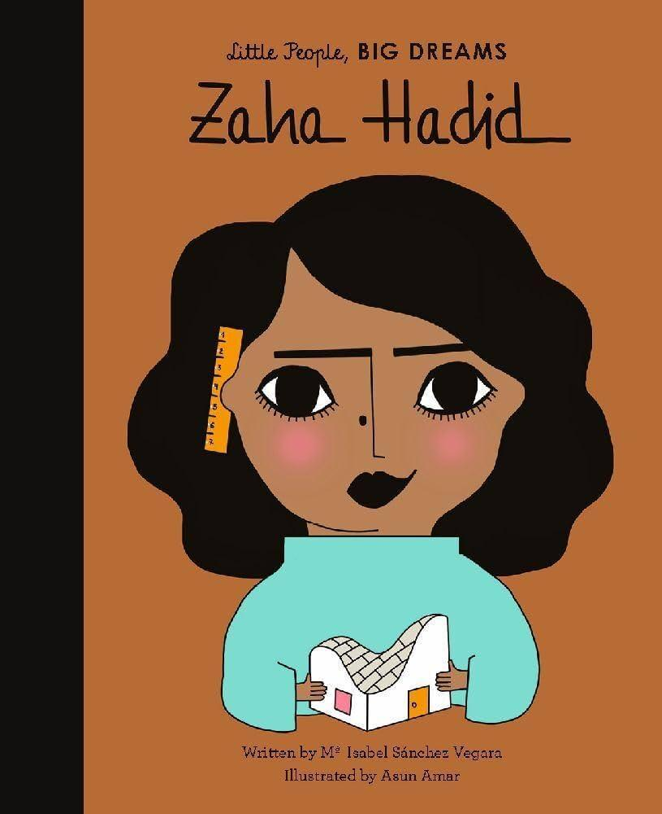 |  | Religion and Worldviews  How do people express their spirituality?  - Pupils explain their understanding of ‘spiritual’ and explain some ideas and beliefs that are important to them.  - They discuss how some Christians express their beliefs using visual imagery. They recognise that Muslims use other forms of art, such as pattern, instead of images. Pupils explore how words and poetry, music and dance are used by some faiths as an art form and to express beliefs.
PSHE  Story Project  The Hundred Dresses  I can tell you the characteristics of a good friend.  I can tell you some ways I can manage friendship problems.  I can tell you what impact bullying or cyberbullying can have and how someone experiencing bullying can stand up to this or get help.  I can tell you how bystanders can help prevent bullying.  I can tell you some ways that I can improve my friendships.  Ossiri and The Bala Mengro  I can tell you the benefits of community participation on my mental wellbeing.  I can tell you how music can benefit my mental wellbeing.  I can tell you why it is important to not give up when something is hard.  I can use a 5 point scale to tell you how hard I am finding my work and I can tell you some strategies that help me when my work is hard.  I can give constructive support and feedback to others. | Music  - Listen and appraise  - Performance  Ukulele  Play and perform in solo and ensemble contexts, using their voices and playing musical instruments with increasing accuracy, fluency, control and expression |  | P.E  Athletics  - use running, jumping, throwing and catching in isolation and in combination  - develop flexibility, strength, technique, control and balance  Cricket  - play competitive games, modified where appropriate and apply basic principles suitable for attacking and defending
Art  Monochromatic  • Produce creative work, exploring their ideas and recording their experiences  • become proficient in drawing, painting, sculpture and other art, craft and design techniques  • evaluate and analyse creative works using the language of art, craft and design  • know about great artists, craftmakers and designers, and understand the historical and cultural development of their art forms  • create sketchbooks to record their observations and use them to review and revisit ideas  • improve their mastery of art and design techniques, including drawing, painting and sculpture with a range of materials [for example, pencil, charcoal, paint, clay]  • learn about great artists, architects and designers in history | Design Technology  Egyptian Collars  - Demonstrate their ability to use cross-stitch as a decorative feature or to join two pieces of fabric together.  - Develop appliqué designs based on design criteria.  - Design, cut and shape their template for an usekh or wesekh collar with increasing accuracy.  - Decorate their Egyptian collar using a variety of techniques, such as appliqué, cross-stitch, beads, buttons and pinking.  - Measure and attach a ribbon with a running stitch.  - Recognise different types and qualities of fabrics.  - Explain the aesthetic and functional properties of some of their material choices. |  | MFL French  Transport  - Explain strategies for working out the meaning of words.  - Recognise nouns that are cognates or near cognates.  - Recognise transport words in written form.  - Join in with a song using actions to aid recall.  - Form simple statements about a picture, using and adapting a model.  - Create a range of different phrases using a sentence builder.  - Generally, speak words with accurate pronunciation.  - Write a simple sentence, using a model for support and using two different accents.  Circle of life  - Source new vocabulary from the dictionary and apply the appropriate indefinite article (un/une).  - Build a range of sentences from a model, selecting appropriate vocabulary.  - Recognise key vocabulary and structure clues, and use scientific understanding to solve a puzzle.  - Attempt to decode new sentences by using their context and sentence structure.  - Apply understanding of the sentence structure to generate new phrases.

