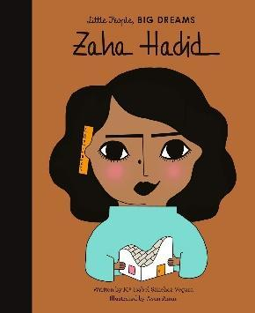
Important Dates
Start of term – 13.4.26
May Day – 1.5.26
Bank Holiday (school closed) – 4.5.25
Year 6 SATs – WC 11.5.26
Wellbeing day – 21.5.26
End of half term – 22.5.26
Back to school – 8.6.26
Y3 Sleepover – 19.6.26
Come and play with the Halle – 25.6.26
Art & DT showcase – 9.7.26
Sports Day – 20.7.26
Last day of term 22.7.26

Autumn Curriculum
In History, we will be studying Ancient Egypt and in Geography answering the question ‘Are all settlements the same?’.
In Science, we will be studying light. Investigating uv light, shadows and reflective materials. We will continue to be creative in Art and DT. Along with RE, Computing, French and PSHE. In Year 3, we will be having weekly ukulele lessons on a Tuesday along with weekly singing assembies..
For further information on other subjects, please check the class page on the school website to keep up to date with our medium term plan for Spring term.
Water Bottles & Packed Lunches
Children are encouraged to bring water bottles to school as it is important that we are hydrated so we can work and be focused fully. Children are not to bring water bottles with spray functions on them.

These will be stored by the sink and children will be encouraged to drink these at playtime and lunchtime. If a child requires a drink during a lesson, it is the teacher’s discretion to find a suitable time.

We are a healthy food school so please encourage children to have healthy foods in their packed lunches and for snack at break time.

PE
Our PE is on a Thursday this year. Please come to school dressed in your full kit: black jogging bottoms and hoody top with a house colour t-shirt. Make sure that your water bottle is brought in and full especially on PE days.
Reading

At Clayton Village, we want all children to be readers and it is a value we encourage. Not only for academics but more for joy and escapism from the everyday world.
Children in Year 3 should read at least 3 times a week. They do not need to read aloud to an adult but you are encouraged to ask your child questions about what they have read. We will have a weekly timetabled ‘Book Talk’ session where children and staff can share and recommend their favourite books. We will also have a DEAR (drop everything and read) session where children can enjoy their reading book.
We will be visiting the library weekly on Fridays so your child will have another opportunity to select a book. Children will also be given a book from the classroom which they will need to bring into school everyday in their school bag.

Mrs Hampson and Mr Kowal

Year 3 – Zaha Hadid
Welcome back Year 3! Hope you had a lovely Easter break.

Mrs Devanney will be teaching on Tuesday, Wednesday and Thursday. Mrs Whitaker will be teaching on Monday and Fridays. They will also continue to have specialist teaching from Mr Waterman, Mrs Battye and Mrs Topley. Mr Kowel is our class TA.

A reminder for parents to name label absolutely everything your child brings to school including their lunch box (if they bring one).

Summer Term 2026

