History  How did the achievements of the Ancient Maya impact their society and beyond?  Knowledge:  - Investigating historical and archaeological evidence, children explore the achievements of ancient peoples like the Maya.  - By making inferences and observing artefacts, they study the ancient Maya’s settlements in rainforests, the cultural significance of chocolate and the impact of their beliefs, inventions and decline within and beyond their society. | Science  Forces – Why can’t we walk on the ceiling?  Knowledge:  - Explain that unsupported objects fall towards the Earth because of the force of gravity acting between the Earth and the falling object  - Identify and explain the effects of water resistance  - Explain how a lever and a pulley works  - Explain that levers and pulleys allow a smaller force to have a greater effect  - Explain that weight is a force  - Explain that gravity is a force  - Explain the Moon is many times smaller than the Moon so gravity on the Moon is very much smaller than on the Earth.  - Explain why there is no atmosphere on the Moon so no air resistance. If they are released at the same instant, both the heavy object and the very light object reach the ground at the same time.  Scientific Enquiries:  - Why does the Moon not fall out of the sky? (pattern seeking)  Properties and Materials  - Describe the properties of objects  - Compare and group everyday objects based on their properties  - Explain what dissolving means and give examples  - Explain what filtering and sieving are and give examples  - Explain how materials can be recovered from solutions or mixtures through evaporation, filtering and sieving.  - Describe reversible and non-reversible changes including examples. E.g. burning wood, rusting, mixing vinegar and bicarbonate of soda  Scientific Enquiries:  - How can we clean dirty water? (Comparative and fair testing) |  | Geography  Would you like to live in the desert?  Knowledge:  - Identify the lines of latitude where hot desert biomes are located.  - Describe the characteristics of a hot desert biome.  - Locate the largest deserts in each continent.  - Describe ways the Mojave Desert is used.  - Name and describe the physical features found in a desert.  - Identify how humans use the desert.  - Explain how human activity may contribute to the changing climate and landscape of a desert.  - Recognise that the Mojave Desert has a different time zone to the UK.  - Describe some of the threats to deserts.  - Give the benefits and drawbacks of living in a desert environment.  - Identify characteristics of two contrasting biomes and compare land use.  - Discussing if a desert environment is hospitable and why.
Computing  Computer Networks – Search Engines  - To create and export an interactive presentation, including a variety of media, animations, transitions and other effects.  - To enhance digital photos and images using crop, brightness and resize tools. | Ada Lovelace  Summer Curriculum  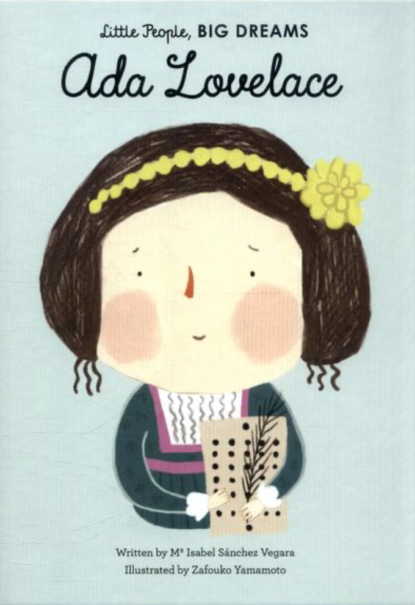 |  | R.E  How might pilgrimage transform people’s lives?  Knowledge:  - Explore places of pilgrimage for Christians, Jews, Muslims, Sikhs and Hindus.  - Understand how pilgrimage makes people of faith feel.  - Express ideas about what people of faith might gain from their special journey.  - Understand that places can be special to more than once faith.
PSHE – Story Project  Pizza Face:  - I can tell you the basic changes that happen during puberty.  - I can tell you how my emotions will change during puberty.  - I can explain that all people will experience puberty differently.  - I can tell you some strategies to positively manage puberty  - I can tell you all the positive things about growing up.  The Boy who Grew Flowers:  - I can describe why it is important to respect my body and the amazing things it can do. I can explain the term ‘body image’ and how my opinion of my body can affect my confidence  - I can explain how images in the media do not always reflect reality and can affect my body image  - I can explain the term self-esteem and know strategies to help boost my self-esteem  - I can describe the effect that bullying can have on mental wellbeing  - I can think of ways to make my classroom more inclusive |  |  | P. E  Athletics  - Use running, jumping, throwing and catching in isolation and in combination.  Cricket  - Play competitive games and apply basic principles suitable for batting and fielding.
Art  Chromatic  Knowledge:  - Practical Knowledge - using watercolour paints with proficiency, learning to mix skin tones, using ripped paper collages to create a self-portrait, using shapes to guide the composition of a portrait, using measurements to control proportions in a face, using sketches to create lines for painting a miniature.  - Theoretical Knowledge - learning about portraiture miniatures as a form of art, learning about portraiture as a form of art over time and across cultures, understanding how technology can influence art, learning about the work of collagists.  - Disciplinary Knowledge - using the seven elements of art to talk about artwork, considering who decides how much art is worth, considering that we can use art to express something that isn't visible, considering how art can be an exploration of who we are and how we want others to see us, considering how colour can be used in portraiture, evaluating our own art process. | Design Technology  Textiles – Waistcoats  - Consider a range of factors in my design criteria and use this to create a waistcoat design.  - Use a running stitch to join fabric and attach a secure fastening, as well as decorative objects.  - Evaluate my final waistcoat. | Music  The Fresh Prince of Bel-Air  Ukulele  - Listen, appraise and perform | MFL  Meet my French Family  - Listen attentively to spoken language and show understanding by joining in and responding.  - Explore the patterns and sounds of language through sound and meaning of words.  - Engage in conversations; ask and answer questions; express opinions and respond to those of others; seek clarification and help.

