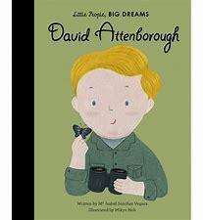  Autumn Curriculum - Home is Where the Heart is  Reception – David Attenborough |  | Overview -  This theme helps support children develop a sense of community as a class, as part of our school family and of their local area.
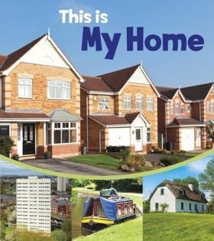
Books
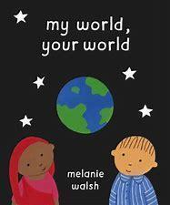
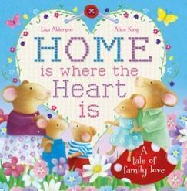
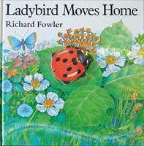
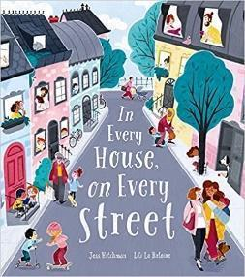
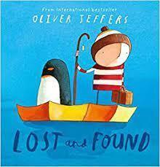
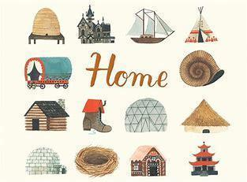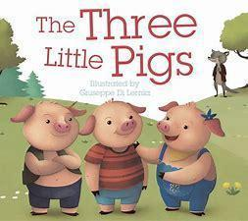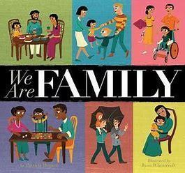
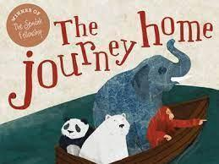

Key Vocabulary
school, Clayton, Clayton Village Primary School, maps, classroom, teachers, home, house, family, friends, Mum / Mummy Dad / Daddy Grandad/Grandpa Nanny/Grandma Brother Sister Baby religion, culture, celebration, wood, soil, brick, mud, straw, concreate, town, village, house, building, design, make, join, past, present, old, new, timeline, chronological, environment, caravan, cottage, shed, bungalow, chimney, habitat, shack, boat, flats, detached, street, post office, park, butchers, body parts arms, legs, shoulder, head, back, knees and bottom, facial features: eyes, nose, mouth, ears, hair, eye brows teeth, same, different, days of the week, numbers 1-10

Friends’ names, hello, goodbye, toilet, help, please, share, wait, kind hands, take turns
Literacy:  We will follow the Little Wandle scheme for phonics learning: s, a, t, p, i, n, m, d, g,o,c,k  is, ck,e,u,r, I, h,b,f, l, the. ff ll ss j, as, v w x y, and has his her, go no to into, sh th ng nk, she he of we me be. Children will practise writing their name 3 times a week and will share daily stories in class and participate in daily nursery rhyme practice. |  | Mathematics:  In maths, we follow the NCETM scheme. Children will participate in daily nursery rhyme practice, daily counting practice and weekly enhanced maths activities during discovery time.
Communication and Language  Skills:  Listening, Attention and Understanding:  - To listen carefully to adults  - Engage in story and song times  - To follow one step instructions  - Have a back-and-forth conversation with a well-known friend  - Make relevant comments on the characters in a story in a simple sentence with a small group  Autumn 2:  - To engage in story times, joining in with repeated phrases and actions  - Ask relevant what/where questions  - To join in with well-known short stories and songs  - To follow two step instructions  - Make relevant comments on the plot in a story in a simple sentence with a small group  - Have a back-and-forth conversation with a well-known adult  Speaking  - To talk in front of a small group (one-word answers)  - To express their ideas and feelings in the present tense  - To participate in one to one discussions offering own ideas (I think..)  Autumn 2:  - To use recently introduced vocabulary in the same context in one to one and small group discussions  - To use conjunctions such as ‘and’  Children to bring photographs of own family and homes and discuss these in class | Expressive Arts and Design  Skills:  Creating with Materials:  - To experiment with using different tools on a variety of types of paper to draw with  - To select preferred painting tool e.g. brush, hand, fingers to create own work  - To experiment with malleable materials e.g., dough, clay, pipe cleaners, straws, papier-mâché pulp  - To cut, roll and coil materials such as clay, dough or plasticine  - To make a print using foam stamps/prints/hands on large paper  - To decorate textiles with glue, to add colour and detail  Autumn 2:  - To add more detail to objects to create recognisable forms  - To name primary colours  - To make a simple collage using different textured materials and glue stick  - To shape and model play dough and add texture using tools  - To make a print using a variety of objects –, bark, plasticine, card, vegetables, polystyrene etc  3D  Using cardboard boxes, tubes, and other recycled items to make a simple castle/building and junk modelling structures.  - Safely use and explore a range of materials, tools and techniques, experiment with colour, design, texture, form and function – teaching different techniques for joining materials.  Black and White Patterns and Mark-Making  Making a simple pattern grid and drawing lines, dots, crosses, squiggles in different black and white media (pencil, crayon, chalk, graphite)  Fairytale Buildings  Drawing an imaginary building that would be in a fairytale.  Exploring Warm and Cold Colours  Creating a painting using warm colours and then another using cold colours.  Collage  Creating a basic collage, tearing up/cutting out pieces from mark-making sheets and painted colour sheets to make an imaginary building.  Printing  Different types of black and white mark, using a range of tools and found objects including natural objects, corks, sponges and forks.  Develop storylines in their pretend play – Learn the Three Little Pigs story (story mapping) and showcase this to year 1.  Artists:  Hundertwasser  Exploring his paintings and his buildings. What building would you create if you could?  Laura Slater  Leeds based textile print artist. Inspiration for mark-making.  Being Imaginative and Expressive:  - To sing echo songs and perform movements to a steady beat  - To explore singing at different speeds and pitch to create moods and feelings  - To listen to music and respond using hand and body movements  - To experiment performing songs with music together with body movements to a steady beat | Physical Development  Skills:  Fine Motor Skills:  - To use a dominant hand  - To mark make  - To use tripod grip when using different tools i.e. paint brush  - To copy patterns and lines  - To thread beads  - To begin to copy letters  - To start to write own name with support  - Can open and close scissors, make random cuts on paper and can cut in a forward motion  - Tools: scissors, pencil, crayons, chalk, whiteboard pens, tweezers, thick paint brushes beads and threads, peg boards  Autumn 2:  - To write own name  - To use anticlockwise movements when writing and mark making  - To start to use tripod grip when writing  - To accurately draw lines and circles  - Can cut in a straight line keep scissors level and cut out simple shapes with one of more change in direction  Gross Motor Skills:  - Me and Myself: getting changed, behavioural expectations in the setting, my body, parts of the body, senses, on the move, can you...  - Movement and Development: How to move, how to move safely, exploring movements, moving in different ways, moving in different directions, moving at different speeds. | Personal, Social and Emotional Development  Skills:  Self-Regulation:  - To recognise feelings in characters  - Offer suggestions for the characters to regulate their emotions  - To say what you want to do in discovery time  - Participate in turn taking games with an adult  - To stop play and conversation when asked by an adult  Autumn 2:  - To recognise feelings in peers  - Offer suggestions for peers (social stories)  Managing Feelings:  - To put their own coat on  - To wash hands after discovery, the toilet and before lunch  - To know the class rules  - To have confidence to explore different parts of the classroom  Autumn 2:  - To put on their own wetsuit trousers and wellies  - To identify and name familiar healthy and unhealthy foods  - Explain the reasons for the class rules  - To help others show independence, resilience and perseverance in the face of a challenge  Building Relationships:  - To play with one other child in the same activity  - To make one friend in class  - Seek support of adults when needed  Autumn 2:  - To play with a small group of children in the same activity  - To use taught strategies when turn taking with one other child
Understanding the World
Past and Present:
- Peek into the past - Opportunities for the children to reflect on memories and experiences from their own past and comment on images of familiar situations in the past. Children will look for similarities and differences between photos, images and objects from the past and present day.
People, Culture and Communities:
Which places are special to members of our community?
Special places can make people feel excited or calm. Special places can be outside in nature or in a building. People can go there alone or with their family / friends.
People of different religions go to places of worship to pray or give thanks.
Why are some objects special?
- Families are all different but can be similar in some ways.
- Objects can be precious because of where they came from, who gave them to us or how they make us feel.
- We need to treat special objects with care and respect.
- Jewish people often have a mezuzah on their door at home. They touch the mezuzah to remind them of God.
- The Torah is a special book for Jewish people. The scroll is written in the language of Hebrew and wrapped in a cover.
- Christians have special objects like a cross, candle and beads that help them think about Jesus. The bible is their holy book.
- The Muslim holy book is the Qur'an. It is about Allah and his followers. It is kept on a high shelf and handled very carefully.
- Hindus families worship at home using a puja tray to offer light, incense, flowers and food.
How do people celebrate special times? (Autumn and Winter)
Chinese New Year is a cultural festival, not a religious one.
Holi is a Hindu celebration of spring, love and new life.
Eid ul-Fitr is a celebration at the end of a period of fasting.
Sikhs parade through the streets to mark the festival Vaisakhi.
Shrove Tuesday, Mardi Gras and Ash Wednesday mark the beginning of lent for Christians – a reflective period of 40 days leading to Easter.

Exploring Maps - Exploring maps through discussion, story-telling, games and creative activity, children look at how features are represented and think about the meaning behind shapes, lines and colours on maps.
- To talk about their homes and families
- To find their way around school
- To talk about and identify main features of their immediate environment - school and home
- To begin to name features of local environment, school, house, home, road, park
- To make basic observations of the local environment
- To talk about where they live - England, Bradford and Clayton
- To know their school is Clayton Village Primary School

The Natural World:
Our Body
- To ask questions about the natural environment
- To know and recognise some signs of Autumn
- To know different body parts and what they are used for, how our bodies change from when we are a baby.
- To know how and why we are all unique and different from one another
- Exploring maps through discussion, story-telling, games and creative activity, children look at how features are represented and think about the meaning behind shapes, lines and colours on maps.

Experiences:
Walk around school and the school grounds
Explore the weather outside (top garden)
Visit from key adults in school
Local walk around Clayton
Visit the local library
Visit from theatre company (Christmas)

