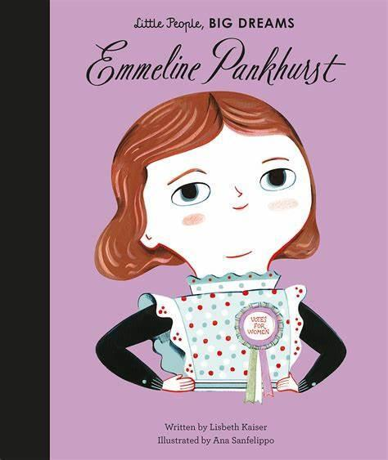
Year 2 – Emmeline Pankhurst
Welcome from your class teacher, Mrs Cooper and your teaching assistant, Mrs Roddis and Miss Feather. We are so excited to welcome the children back to CVPS and we can’t wait to watch them progress in Year 2. Our class name is Emmeline Pankhurst and we will be learning about why she is an important figure this half-term.

Reading
At Clayton Village, we want all children to be readers and it is a value we encourage. Not only for academics but more for joy and escapism from the everyday world.

Children should read at home at least 3 times a week. Please record this in your child’s Reading Record.
Your child will bring their new reading book home on a Wednesday and must return it to school the next Monday.
We will be visiting the library every week so your child will have another opportunity to select a book.

Important Dates
Parent Morning – 04.09.26
School Election Day – 05.10.26
Parents evening – 14.10.26
Halloween Disco – 21.10.26
Break up for half term – 23.10.26
Back to school – 02.11.26
STEM Showcase – 25.11.26
KS1 Christmas Performance – 14.12.26
Christmas Disco – 16.12.26
Panto – 16.12.26
Christmas lunch – 17.12.26
Break up for Christmas holidays – 18.12.26

PE
Our PE is on a Wednesday this year. Please come to school dressed in your full kit: black jogging bottoms and hoodie top with a house colour t-shirt. Make sure that your water bottle is brought in and full especially on PE days.
Water Bottles
Children are encouraged to bring water bottles to school as it is important that we are hydrated so we can work and be focused fully. Children are not to bring water bottles with spray functions on them.
Autumn Curriculum
Our topic for this term is ‘Adventures in the City.’ We will be learning about the history of our city. This will include looking at what schools were like in the past. In Geography, we will be comparing hot and cold places. Have you ever visited a hot or cold place? Would you be able to tell us any information about this? We will also be researching about a local Bradford artist, David Hockney. You could continue learning at home by researching the city of Bradford and how it has changed e.g. looking at old pictures and learning about the lives of significant people.
For more information, please see the school website.

Autumn Term 2026
Personal belongings
Children can bring a bag to school to bring home letters, uniform and other important pieces of information. We ask that all personal belongings remain at home. Children do not need to bring any equipment from home. However, they must bring their bag with them every Monday and Wednesday to have their book changed.
Please name label absolutely everything your child brings to school including their lunch box (if they bring one).
Coats and jumpers are regularly taken on and off and will usually be returned if clearly named.

